# Understanding and questioning images using the five-step process

## Contents

Introduction 2

The five step method 2

Try it yourself (exercise) 2

Over to you 7

Summary 8

References 8

Full URLs 9

## Introduction

From memes to Instagram, our increasingly hyper-visualised society makes the ability to read images (visual literacy) a vital skill.

This interactive tutorial will give you the skills to read images using a five-step process to enable you to analyse and understand images and their implicit meanings.

“In an era in which gossip has become more about pictures than words, it was inevitable, then that the paparazzi were never far away” (Willis, 2016).

Back to Contents

## The five step method

For an introduction to the five-step method of understanding and questioning an image, click the video link below or read the transcript.

[Understanding and questioning images using the 5 step process](https://digitalmedia.sheffield.ac.uk/media/1_774362n5)

## Try it yourself (exercise)

Having watched the video, you can now try to apply this method to an image.

The image will be split onto quadrants (see next page) and you can write your ideas down. Once completed you can see how you did and find out more information to check your understanding.

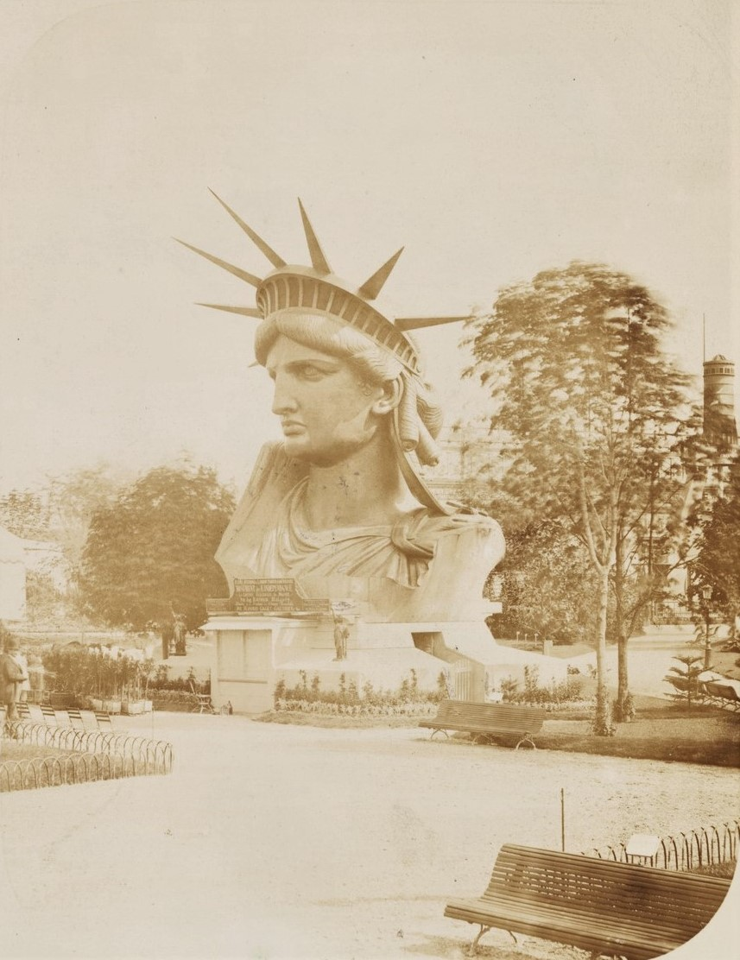

[Head of the Statue of Liberty on display in a park in Paris](https://digitalcollections.nypl.org/items/510d47de-0a2d-a3d9-e040-e00a18064a99) from [The New York Public Library Digital Collections](https://digitalcollections.nypl.org/) (Public domain)

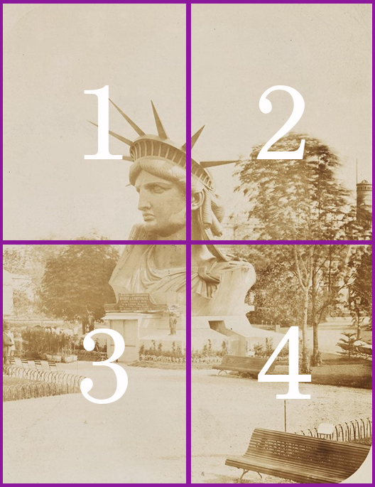

[Head of the Statue of Liberty on display in a park in Paris](https://digitalcollections.nypl.org/items/510d47de-0a2d-a3d9-e040-e00a18064a99) from [The New York Public Library Digital Collections](https://digitalcollections.nypl.org/) (Public domain)

### Step 1: Gaze

What do you see and what is happening? A model answer is given below for each quadrant.

1. We can see the head of the Statue of Liberty in a park with the tops of trees. This is not the setting we are used to – which is on an island in New York’s Hudson River.
2. We can see the head of the Statue of Liberty in a park with the tops of trees. We can also see a building in the background. Again, this is not the normal surrounding we are used to seeing when looking at the Statue of Liberty.
3. We can see a plinth with the neck of the Statue of Liberty. We can also see a little gate leading into the monument, as well as park benches.
4. We can see the shoulder area of the head. There is also a sign with writing. There are two people looking at the statue, as well as trees and benches.

### Step 2: Read

Is there text in the image? What new information does this text tell you about the image? A model answer is given below for each quadrant.

1. No text in this quadrant.
2. No text in this quadrant.
3. No text in this quadrant.
4. We can see a sign on the plinth. The text is difficult to see and in French, but it possibly says:
5. Line 1: Symbole de l'amitié Franco-Américaine
6. Line 2: ‘Monument de l'indépendance’
7. Line 3: La Liberté éclairant le monde
8. Line 4: Statuaire
9. Line 5: [Unable to make any text out on this line]
10. Line 6: Monduit - Gaget, Gauthier

### Step 3: Infer

Match what you have seen in the image to the text you’ve read to gain new understanding of the image. A model answer is given below for each quadrant.

1. We saw that the surroundings do not match the usual surroundings of the Statue of Liberty and that the rest of the statue is missing. This infers that the statue is somewhere other than the United States of America. The caption of the image supports this theory.
2. We saw that the surroundings do not match the usual surroundings of the Statue of Liberty and that the rest of the statue is missing. This infers that the statue is somewhere other than the United States of America. The caption of the image supports this theory.
3. The plinth has an entrance, why is that? Is it for people to look around inside the monument? Was the monument there to raise awareness or money for the project to build and ship the statue to the United States of America?
4. The text confirms that this is the head of the Statue of Liberty. The text is in French - and says that it is a ‘symbol of Franco-American Friendship’. It also says that it is an ‘Independence Monument. It also gives the name ‘La Liberté éclairant le monde’ – Liberty Enlightening the World. We also have the text Monduit and Gaget Gauthier – This appears to be the foundry in which the materials for the statue were made.

### Step 4: Articulate

What is the deeper meaning of the image? How do design choices, the intended audience and purpose of the image influence this? A model answer is given below.

The purpose of the image is to document the historically important development of the Statue of Liberty. This is clear, as the picture is formal and imposing with the head of the statue at the centre. The statue is the key feature. It is also from a New York Public Library collection, which would suggest some historical importance. The image in is black and white/sepia – this suggests that it is an old photograph. The date supports this.

### Step 5: Develop or further understanding

#### Metadata about the image

**Artist**: Albert Fernique

**Title**: Head of the Statue of Liberty on display in a park in Paris

**Date**: 1883

**Medium**: Photograph – Still image

**Provenance**: The Miriam and Ira D. Wallach Division of Art, Prints and Photographs: Photography Collection

**Credit**: From [The New York Public Library Digital Collections](https://digitalcollections.nypl.org/" \o "The New York Public Library Digital Collections)

#### Information gathered from background reading is given below:

The erection of the Statue of Liberty was threatened by a lack of funds (Trachtenburg, 1976, p.181). The statue was exhibited at Paris’s World Fair in 1878 with only the first part completed (Trachtenburg, 1976, p.181).

Fundraising occurred with tickets available to view the construction site, and a lottery was held (The Statue of Liberty – Ellis Island Foundation, ©2018).

The head was permitted to be displayed as it permitted visitors to enter and climb a viewing platform (Trachtenburg, 1976, p.125). The statue was a gift from the French to America to celebrate the centennial of independence and their friendship.

The location of the statue in America was chosen as the island could be seen by anyone who entered the country via New York (National Park Service, 2015). The statue was envisioned as being able to “visually control the entrance to the free world” (Trahctenburg, 1976, p.149).

Back to Contents

## Over to you

“All images carry meanings that can only be understood through a contextualization of how, when, where and why they were produced. Images do not exist in a vacuum. Situate images within the framework of their social, political, and economic circumstances.” (Brown *et al*., 2016, p.2)

Images are often used to represent meanings beyond what you literally can see within it. Suggestion or metaphor can be what gives the image its impact. Photographs in particular are often reproduced these days out of their original context, for example in memes. It is important to question and understand why a particular image was chosen, and how things like added text can create an entirely new context for that image.

Now that you understand the modified five step process for understanding and questioning images, you will be able to apply this not only within your studies but also in your everyday life in today's highly visualised culture.

Back to Contents

## Summary

You have reached the end of this resource. This information has been adapted from the [Understanding and questioning images using the five step process tutorial](https://vle.shef.ac.uk/bbcswebdav/xid-48061222_1).

Why not look at some of our other Research Skills and Critical Thinking resources? [Book onto a Workshop or take an Online Tutorial](https://www.sheffield.ac.uk/library/study/research-skills).

Remember to reflect on and record your skills development using [mySkills](https://www.sheffield.ac.uk/skills/myskills).

Visit our FAQs: [Library FAQs](http://libraryhelp.shef.ac.uk/)

Get in touch: [library@sheffield.ac.uk](mailto:library@sheffield.ac.uk)

[Back to Contents](#_Contents" \o "Back to Contents)

## References

Brown, N. E. *et al*. (2016) *Visual literacy for libraries: a practical, standards-based guide*. London: Facet Publishing.

Imperial War Museum (©2018) *Women of Britain Say ‘Go’*. Available at: <https://www.iwm.org.uk/collections/item/object/14592> (Accessed: 7 February 2018).

Kealey, E. J. (1915) *Women of Britain Say ‘Go!’* [Poster]. Available at: <http://www.iwm.org.uk/collections/item/object/14592> (Accessed: 7 February 2018).

National Parks Service (2015) *Creating the Statue of Liberty*. Available at: <https://www.nps.gov/stli/learn/historyculture/places_creating_statue.htm> (Accessed: 1 February 2018).

The Statue of Liberty - Ellis Island Foundation (2018) *Engineering, constructing, and crossing the Atlantic*. Available at: <https://www.libertyellisfoundation.org/statue-history> (Accessed: 1 February 2018).

Trachtenberg, M. (1976) *The Statue of Liberty*. London: Allen Lane.

‘White Feather “favours”’ (1914) *Daily Mail*, 2 September. Available at: <https://go-gale-com.sheffield.idm.oclc.org/ps/i.do?p=GDCS&u=su_uk&id=GALE|EE1864070618&v=2.1&it=r&sid=GDCS&asid=d5de1174> (Accessed: 15 August 2023).

‘White Feather campaign’ (1914) *Daily Mail*, 1 September. Available at: <https://go-gale-com.sheffield.idm.oclc.org/ps/i.do?p=GDCS&u=su_uk&id=GALE|EE1863449484&v=2.1&it=r&sid=GDCS&asid=534ee67b> (Accessed: 15 August 2023).

Willis, D. (2016) ‘Why should the Brangelina split matter?’ *BBC News*, 24 September. Available at: <http://www.bbc.co.uk/news/entertainment-arts-37452862> (Accessed: 15 August 2023).

## Full URLs

Understanding and questioning images using the 5 step process (video) <https://digitalmedia.sheffield.ac.uk/media/1_774362n5>

IWM Non-Commercial License: <https://www.iwm.org.uk/corporate/policies/privacy-copyright/licence>

The New York Public Library Digital Collections: <https://digitalcollections.nypl.org/>

Head of the Statue of Liberty on display in a park in Paris: https://digitalcollections.nypl.org/items/510d47de-0a2d-a3d9-e040-e00a18064a99

Understanding and questioning images using the five step process: <https://vle.shef.ac.uk/bbcswebdav/xid-48061222_1>

Research Skills and Critical Thinking Workshops and Tutorials: <https://www.sheffield.ac.uk/library/study/research-skills>

mySkills: <https://www.sheffield.ac.uk/skills/myskills>

Library FAQs: <https://libraryhelp.shef.ac.uk/>

University Library’s referencing page: <https://www.sheffield.ac.uk/library/study/research-skills/referencing>

[Back to Contents](#_Contents" \o "Back to Contents)

Last reviewed: September 2024

Review due: Summer 2025



Except otherwise noted, this work by The University of Sheffield Library is licensed under the Creative Commons Attribution-NonCommercialShareAlike 4.0 International License. To view a copy of this license, visit http://creativecommons.org/licenses/by-nc-sa/4.0/.