# Developing a search strategy

## Contents

[Contents 1](#_Toc46221346)

[Introduction 2](#_Toc46221347)

[Learning objectives 2](#_Toc46221348)

[Developing your search strategy 2](#_Toc46221349)

[Identify search terms 2](#_Toc46221350)

[Alternative search terms 1 3](#_Toc46221351)

[Alternative search terms 2 3](#_Toc46221352)

[Mind mapping 3](#_Toc46221353)

[Phrase searching 4](#_Toc46221354)

[Combining search terms 4](#_Toc46221355)

[Combining search terms for the same concepts: OR 4](#_Toc46221356)

[Combining search terms for different concepts: AND 5](#_Toc46221357)

[Excluding search terms: AND NOT (or just NOT) 5](#_Toc46221358)

[Quiz 6](#_Toc46221359)

[Which operator is this? 1/4 6](#_Toc46221360)

[Which operator is this? 2/4 6](#_Toc46221361)

[Which operator is this? 3/4 6](#_Toc46221362)

[Which operator is this? 4/4 6](#_Toc46221363)

[To conclude 6](#_Toc46221364)

[Summary 6](#_Toc46221365)

[Full URLs 7](#_Toc46221366)

## Introduction

Investing some time in planning your search strategy can help you save time and find relevant results quickly.

## Learning objectives

By the end of this tutorial you will be able to:

* Identify the main keywords and concepts of a question.
* Produce a list of alternative terms or related concepts.
* Combine search terms in an effective search strategy.
* Apply key aspects of the search strategy when using Scopus, a multidisciplinary database

[Back to Contents](#_Contents)

## Developing your search strategy

A search strategy combines keywords and alternative terms in a comprehensive search which can then be used in an academic database.

Academic databases are specialist search tools which index a wide selection of academic sources. They are designed for undertaking thorough and precise searches of journal articles, conference papers, book chapters and more all from one place.

The Library provides access to many different academic databases. Each one covers a different range of material, and some may focus on a specific academic subject.

Useful multidisciplinary databases for all subjects are [Scopus](https://www.sheffield.ac.uk/library/cdfiles/scopus) and [Web of Science](https://www.sheffield.ac.uk/library/cdfiles/wos).

To find academic databases for your subject, see the Discovering tab in the [Library Subject Guide](https://sheffield.libguides.com/) for your department.

The process of developing a search strategy can be split into two main parts: devising search terms and combining search terms.

However, developing an effective search strategy is an ongoing process and you may need to refine your search terms more than once.

[Back to Contents](#_Contents)

## Identify search terms

This section will show you how to identify search terms and develop alternatives.

The first step is to look at your question or topic and identify the key ideas or concepts.

Imagine you are undertaking a literature review to address the following question: How can sustainable development contribute to well-being? (sustainable development and well-being would be your initial search terms.)

### Alternative search terms 1

The next step is to think of any alternative or related words or phrases that you could use to search for the same concepts.

Bear in mind that many academic databases will automatically take into account spelling variations such as US and UK spelling differences, e.g., US behavior or UK behaviour, US modernization and UK modernisation, and singular and plural terms, e.g., heart attack and heart attacks, including irregular ones, e.g., child/children, criteria/criterion.

Always check in the ‘Help’ section of the database you are using for details.

### Alternative search terms 2

You can also use your search results to help you identify alternative search terms in the following ways:

* Use an online encyclopedia or thesaurus.
* Do a quick search on Google Scholar and see the related searches.
* Look at the keywords linked to relevant articles that you find on academic databases such as Scopus.

See this in Google Scholar: [Identifying alternative search terms (Google Scholar)](https://digitalmedia.sheffield.ac.uk/media/1_tb7s8p58)

See this in Scopus: [Identifying alternative search terms (Scopus)](https://digitalmedia.sheffield.ac.uk/media/1_gexiqgps)

### Mind mapping

Mind mapping can be a useful technique to help you generate further search terms and organise your ideas around your topic or question.

Some people find it more productive to mind map on paper, but there is mind mapping software available such as [MindView](https://www.youtube.com/watch?v=Ta6O4dsdTec), which is available from the Software Centre on networked University computers, or [MindMeister](https://www.mindmeister.com/), which is freely available online.

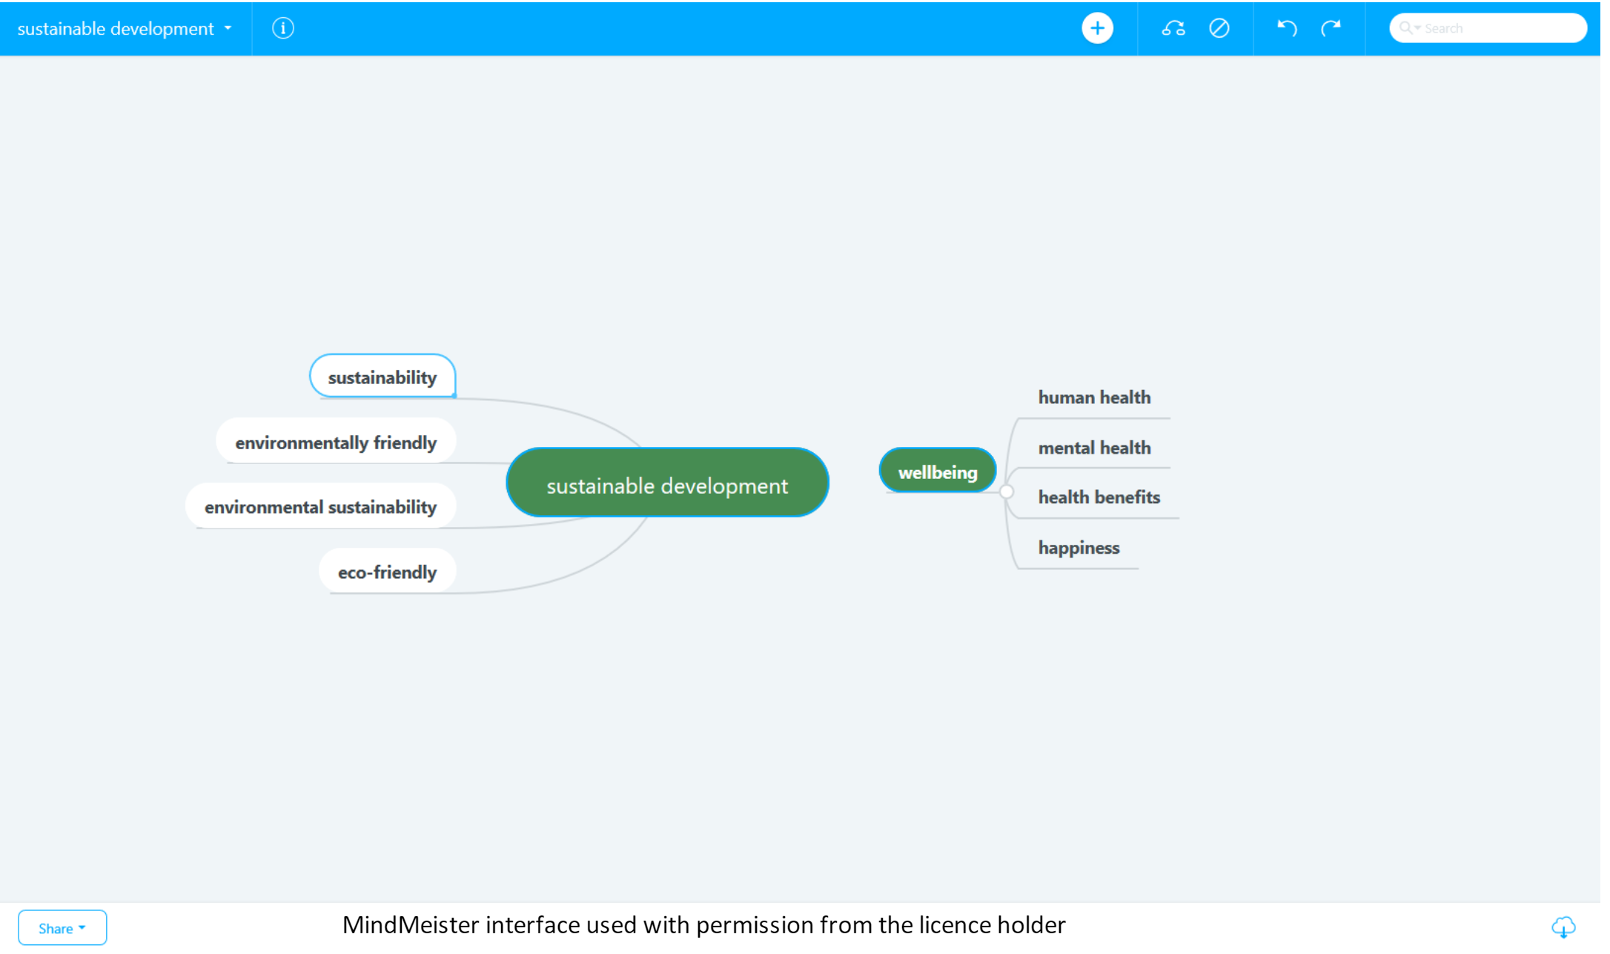

### Phrase searching

Phrase searching is a useful technique if you are searching for a term that is more than one word. If you are searching for a phrase and find you are getting some irrelevant results, try putting your phrase in quotation marks.

This tells the academic database that you only want to see results where the words appear next to each other in a sentence. This can increase both the precision of your search and the relevance of your results.

Watch the video below to see phrase searching in Scopus.

[Phrase searching in Scopus (video)](https://digitalmedia.sheffield.ac.uk/media/1_ns2gv9jm)

[Back to Contents](#_Contents)

## Combining search terms

When searching a database you can use Boolean operators to combine your search terms together to either narrow or broaden your search.

The main Boolean operators are OR, AND, and AND NOT (or just NOT in some databases).

They will make your search both thorough and precise and produce the most relevant search results.

### Combining search terms for the same concepts: OR

You can use the operator OR to combine two or more alternative terms for the same concept. This will find results which contain any of the terms.

Using OR will increase your number of results and make your search more thorough and comprehensive.

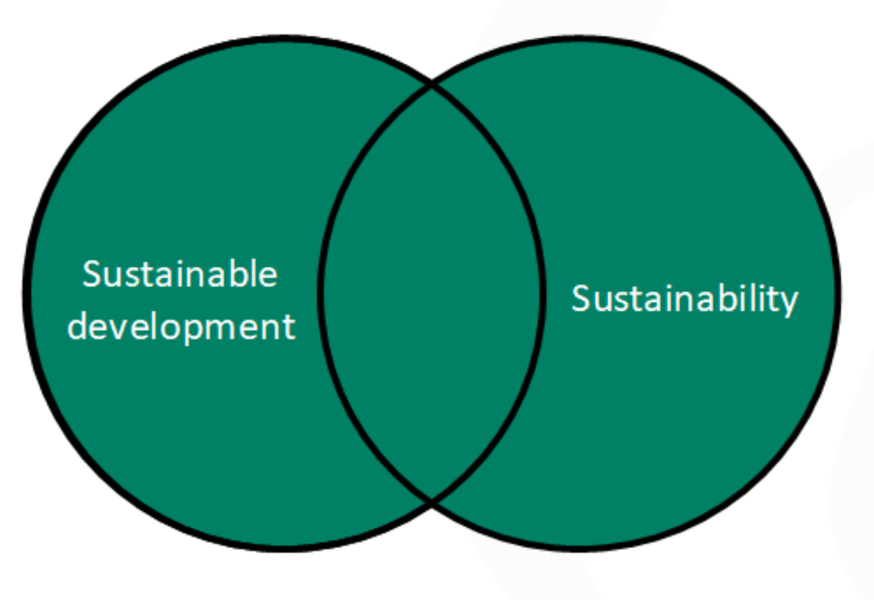

“sustainable development” **OR** sustainability

Watch a demo of the [OR operator in Scopus (video)](https://digitalmedia.sheffield.ac.uk/media/1_gyy8si8a)

[Back to Contents](#_Contents)

### Combining search terms for different concepts: AND

You can use the operator AND to combine terms for different ideas or concepts. This will find only those results which contain all of the terms.

Adding AND will reduce your number of results and make your search more precise and specific.

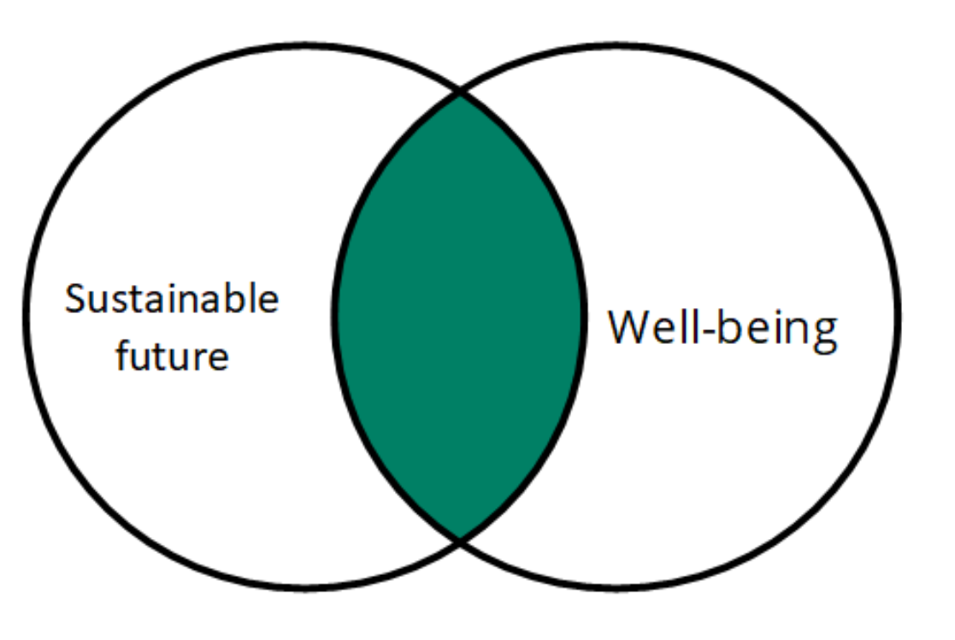

“sustainable future” **AND** well-being

Watch a demo of the [AND operator in Scopus (video)](https://digitalmedia.sheffield.ac.uk/media/1_g4h3zmer)

[Back to Contents](#_Contents)

### Excluding search terms: AND NOT (or just NOT)

To EXCLUDE a term that you don’t want in your results you can use the operator AND NOT (some databases just use the word NOT).

This can be effective if you are getting a lot of results on an aspect of your topic that you are not interested in. You may want to check your results to make sure you have not excluded anything that is potentially useful.

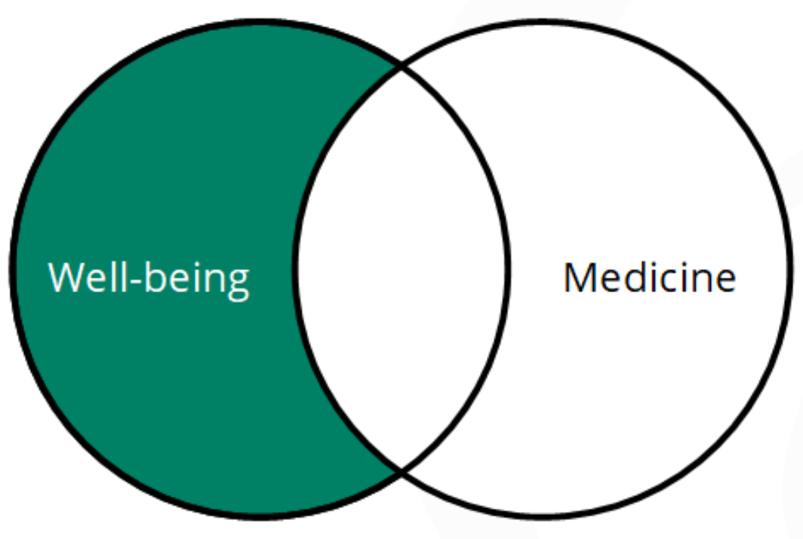

Well-being **AND NOT** medicine

Watch a demo of the [AND NOT operator in Scopus (video)](https://digitalmedia.sheffield.ac.uk/media/1_0xd14pk2)

[Back to Contents](#_Contents" \o "Back to Contents)

## Quiz

### Which operator is this? 1/4

It will only find results where the words in your search appear next to each other in a sentence, and will make your search more specific:

* Correct answer: PHRASE SEARCH

### Which operator is this? 2/4

It will only find results which contain all of your search terms, reducing the number of results and making your search more precise and specific:

* Correct answer: AND

### Which operator is this? 3/4

It will exclude any terms that you want to remove from your search if you find you are getting too many irrelevant results:

* Correct answer feedback: AND NOT

### Which operator is this? 4/4

It will find results containing any of your search terms, increasing the number of results and making your search more thorough and comprehensive:

* Correct answer: OR

[Back to Contents](#_Contents)

## To conclude

Using these techniques where appropriate can help you search in a way that is both thorough and precise.

Remember that there is usually a bit of trial and error involved in planning a search. It is a process and you may refine your search terms as you continue your research.

## Summary

You have reached the end of this resource. This information has been adapted from the [Developing a search strategy tutorial](https://vle.shef.ac.uk/bbcswebdav/xid-48024365_1).

Why not look at some of our other Research Skills and Critical Thinking resources? [Book onto a Workshop or take an Online Tutorial](https://www.sheffield.ac.uk/library/study/research-skills).

Remember to reflect on and record your skills development using [mySkills](https://www.sheffield.ac.uk/skills/myskills).

Visit our FAQs: [Library FAQs](http://libraryhelp.shef.ac.uk/)

Get in touch: [library@sheffield.ac.uk](mailto:library@sheffield.ac.uk)

[Back to Contents](file:///X:\\Library\\Learning%20Services\\IDL%20Tutorials\\IDLT%20cPanel\\public_html\\Assets\\pdfs\\pdf_templates\\communicating-template.docx" \l "_Contents" \o "Back to Contents)

## Full URLs

Scopus <https://www.sheffield.ac.uk/library/cdfiles/scopus>

Web of Science <https://www.sheffield.ac.uk/library/cdfiles/wos>

Library Subject Guides <https://sheffield.libguides.com/>

Identifying alternative search terms (Google Scholar) <https://digitalmedia.sheffield.ac.uk/media/1_tb7s8p58>

Identifying alternative search terms (Scopus) <https://digitalmedia.sheffield.ac.uk/media/1_gexiqgps>

MindView <https://www.youtube.com/watch?v=Ta6O4dsdTec>

MindMeister <https://www.mindmeister.com/>

Phrase searching in Scopus (video) <https://digitalmedia.sheffield.ac.uk/media/1_ns2gv9jm>

OR operator in Scopus (video) <https://digitalmedia.sheffield.ac.uk/media/1_gyy8si8a>

AND operator in Scopus (video) <https://digitalmedia.sheffield.ac.uk/media/1_g4h3zmer>

AND NOT operator in Scopus (video) <https://digitalmedia.sheffield.ac.uk/media/1_0xd14pk2>

Research Skills and Critical Thinking Workshops and Tutorials: <https://www.sheffield.ac.uk/library/study/research-skills>

mySkills: <https://www.sheffield.ac.uk/skills/myskills>

Library FAQs: <https://libraryhelp.shef.ac.uk/>

Developing a search strategy tutorial: <https://vle.shef.ac.uk/bbcswebdav/xid-48024365_1>

[Back to Contents](#_Contents)

Last reviewed: September 2024

Review due: Summer 2025



Except otherwise noted, this work by The University of Sheffield Library is licensed under the Creative Commons Attribution-NonCommercialShareAlike 4.0 International License. To view a copy of this license, visit http://creativecommons.org/licenses/by-nc-sa/4.0/.