# Presentations: Plan, Create & Deliver

## Contents

Contents 1

Introduction 2

Planning 2

Visual aids 3

Good practice when creating slides 3

Using images in presentations 6

Presentation software 6

Don’t forget to reference 7

Delivering your presentation 7

Over to you 8

Quiz answers 9

Summary 9

References 9

Full URLs 10

## Introduction

Presenting is an important transferrable skill. A lot of job interviews now include presentation as part of the selection process and most Higher Education courses also involve presentations as part of coursework. By the end of this tutorial, you will be able to:

* Effectively plan an informative and succinct presentation.
* Create a presentation that conveys an appropriate amount of information with accompanying visual aids.
* Deliver an engaging presentation and make good use of notes.

[Back to Contents](#_Contents" \o "Back to Contents)

## Planning

### Initial planning

Planning your presentation is crucial. Spend about 25% of your time planning what you are going to say. Before you begin writing, check the mark scheme so you know what you are being assessed on. In some cases, you could lose marks for going over, or being significantly under the time limit so it’s vital to stick to the time frame.

### Content

The most successful presentations tend to be more focused. Rather than try to cover too much, aim only to address one main topic. This is not an opportunity to tell the audience everything you know about a topic! Remember that it always takes longer than you think to explain something: a rough guide is ten minutes for every three points you want to make. Being concise in a presentation is all about knowing what you want to say and what you can leave out. Keep thinking *‘What is my point and how does this presentation show it?’*.

### Structure

The best presentations have a clear structure, usually including an introduction, a middle section covering key points, and a conclusion:

* Introduction – Tell your audience what you’re going to tell them.
* Middle Section – Tell them.
* Conclusion – Tell them what you have told them.

Back to Contents

## Visual aids

Visual aids are anything in a written format which help the audience to better understand the points you are making. For example, this could be a handout, slides or a poster which supplement your spoken presentation to illustrate your point.

Visual aids help to structure your presentation by giving the audience something to focus on. Don’t clutter slides with too much text: This would be hard to read and not visually pleasing.

Back to Contents

## Good practice when creating slides

* Select a font that is clear, simple and easy to read. Also, avoid using too many fonts in your presentation (WebAim, 2013). Fonts such as Arial or Times New Roman are normally available on most operating systems.
* Use font size 20-30 on your slides. This will make the text clearer and easier for your audience to read.
* Do not use more than 25 words per slide. This will make your slide look clear and uncluttered.
* Keep the style of your slides consistent and the background uncluttered and simple. This makes your presentation look clearer to the audience.

### Quiz: pick the correct slide

Which slide below has followed the tips shown above? Select one. The answer is given at the end of this document.

Slide 1:

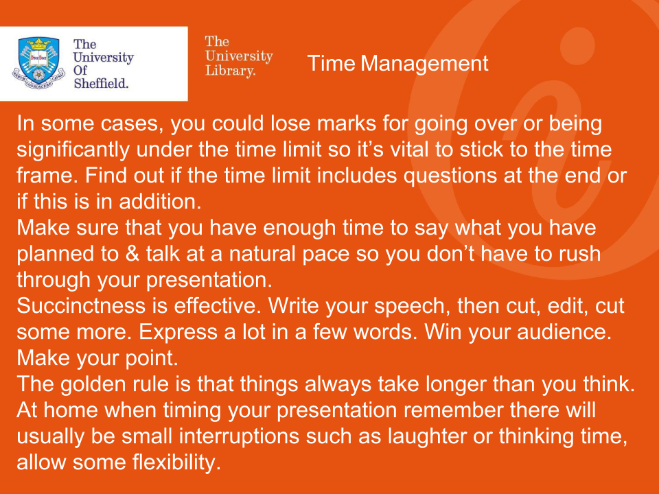

Slide 2:

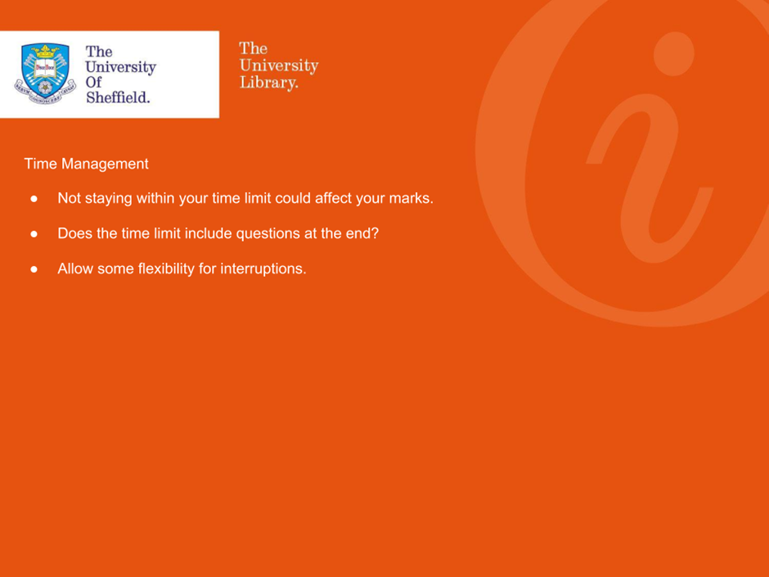

Slide 3:

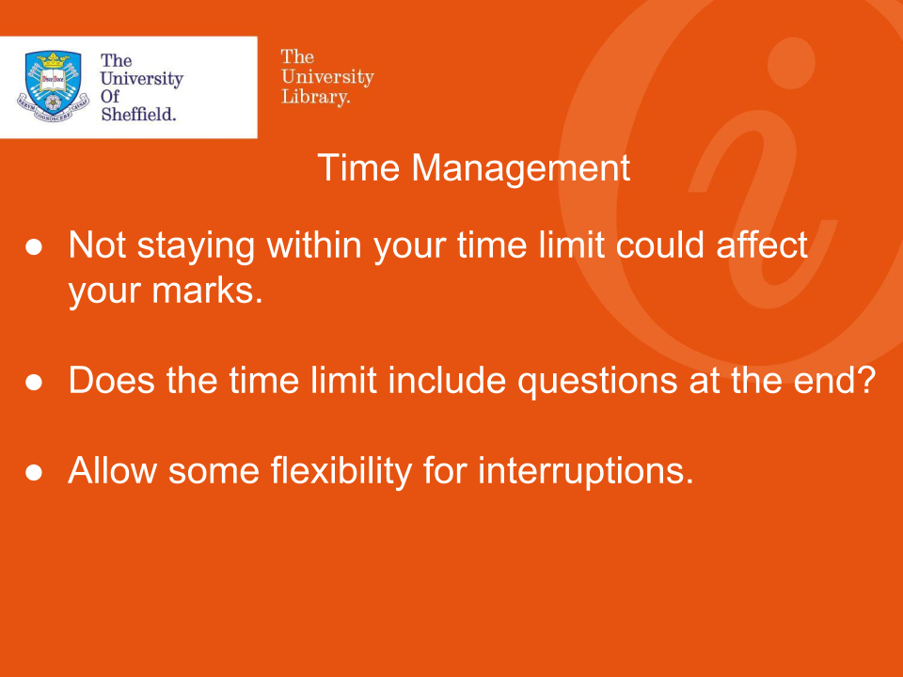

Slide 4:

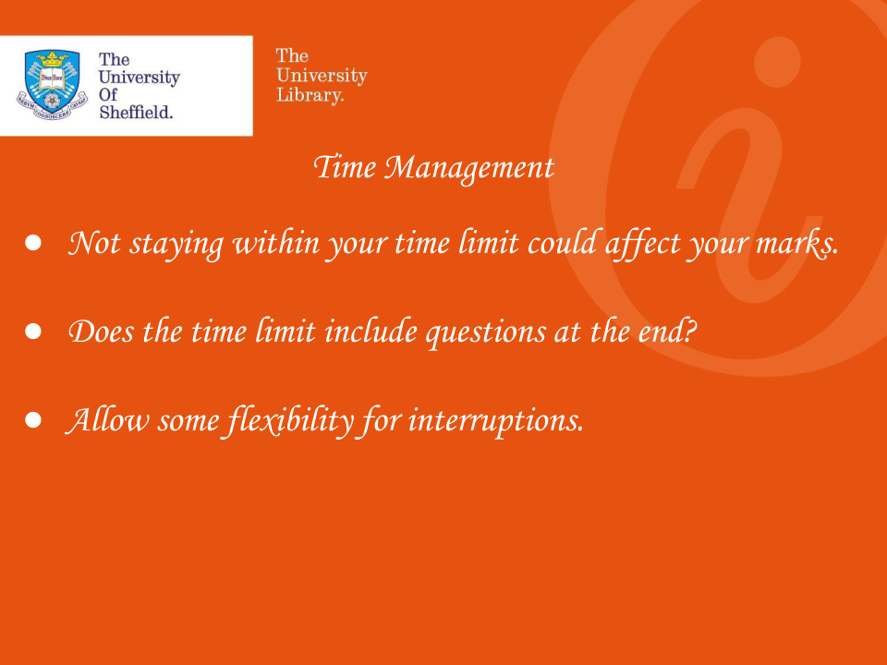

Check your answer

Back to Contents

## Using images in presentations

We process images faster than words – they can create an instant reaction in your audience in a way text can’t. This means that they can be highly effective when used in visual aids for presentations. There are a few key tips to bear in mind when using images in your slides:

* Images in presentations shouldn’t just be for decoration, they should illustrate the points you are making.
* Use an image that takes up the whole slide or half a slide, rather than a small image – this will give it more power.
* Avoid skewing or stretching images if you decide to change the size.

Back to Contents

## Presentation software

There are several types of presentation software for you to choose from, each with their own advantages and disadvantages. Watch the videos below to find out about each software and follow the additional links to access some useful resources to help you use them.

1. [Presentations on **PowerPoint**](https://digitalmedia.sheffield.ac.uk/media/Presentations+on+PowerPoint/1_k8yqrbpe)

* 1. [Create a presentation in PowerPoint (office.com)](https://support.office.com/en-gb/article/create-a-presentation-in-powerpoint-422250f8-5721-4cea-92cc-202fa7b89617?ui=en-US&rs=en-GB&ad=GB" \o "Create a presentation in PowerPoint (office.com))
  2. [Design in PowerPoint (office.com)](https://support.office.com/en-us/article/Design-in-PowerPoint-2659f76c-3297-4ff2-ac55-4aa5eda8113b)

1. [Presentations on](https://digitalmedia.sheffield.ac.uk/media/Presentations+on+Prezi/1_otav5ump" \o "Presentations on Prezi (video)) **[Prezi](https://digitalmedia.sheffield.ac.uk/media/Presentations+on+Prezi/1_otav5ump" \o "Presentations on Prezi (video))**
   1. [How to make a Prezi presentation (YouTube)](https://www.youtube.com/watch?v=SWeXc0nwObc&t=1s" \o "Creating a new presentation (prezi.com))
   2. [Customise a presentation with Prezi Design (YouTube)](https://www.youtube.com/watch?v=Totirr3zxMs&t=15s" \o "Build and customize a stunning presentation (prezi.com))
2. [Presentations on **Google Slides**](https://digitalmedia.sheffield.ac.uk/media/Presentations+on+Google+Slides/1_a0wonsir)
   1. [Get started with Slides (google.com)](https://support.google.com/a/users/answer/9313043#!/)
   2. [Enhance presentations with powerful visuals (google.com)](https://support.google.com/a/users/answer/9310493#!/)
3. [Presentations on **Canva**](https://digitalmedia.sheffield.ac.uk/media/Presentations+on+Canva/1_cbnjt3d5)
   1. [Creating a presentation in Canva (canva.com)](https://www.canva.com/learn/an-easy-guide-to-creating-a-presentation-in-canva/)
   2. [Design Powerful and Engaging Presentations (canva.com)](https://www.canva.com/create/presentations/)

Back to Contents

## Don’t forget to reference

Referencing in a presentation is essential and shows where you have found information to back up your claims.

Referencing is a two-part process:

* **A citation in the text**. Just like an essay, an in-text citation gives a brief indication of the source used, and is placed directly next to the source whether quotes, paraphrased, or summarised. You will also need to reference any images you include. e.g. Smith (2015) claimed that…
* **A reference list**. A complete list of all cited references are usually presented in a slide at the end of your presentation, on a separate slide. In presentations it is acceptable to reference one each slide, however be aware that this can make your slides look cluttered and untidy.

See the **Referencing** section on the Library’s [Research Skills and Critical Thinking Tutorials for school and college students](https://www.sheffield.ac.uk/library/study/schoolsandcolleges) page, or the **Referencing** section on the Library’s [Apprentices](https://www.sheffield.ac.uk/library/study/apprentices) page for more information.

### Example of an in-text citation

What are you being assessed on? Van Emden and Becker (2010) suggest thinking about:

1. Content, structure and accuracy
2. If you are working in a group, your team working skills
3. Your use of notes
4. The way in which you use your voice
5. Your non-verbal communication

### Example of a full reference in a reference list or at the end of a slide

Van Emden, J. and Becker, L. (2010) Presentation skills for students. 2nd edn. Basingstoke: Palgrave Macmillan.

Back to Contents

## Delivering your presentation

### Using notes

* **Do** have brief notes and prompts written on file cards, a phone or tablet which you can use to jog your memory.
* **Do** Use your prompts to remind you of your key points which you can then word naturally during your presentation.
* **Don’t** write in full sentences or you will be tempted to read them.
* **Don’t** use jargon or vocabulary that the audience may not understand.
* **Don’t** use a large sheet of paper for your notes, if you are nervous your audience will see your hands shaking.

### Body language and speech

* Before you start speaking, take a deep breath and smile at your audience – this helps create a relaxed atmosphere.
* Face your audience and make eye contact.
* Speak in a clear voice – loud enough for the people at the back of the room to hear what you are saying.
* Talk at a natural pace – this is usually slower than you think!
* Use pauses to regroup and silence to emphasis points.
* If something goes wrong, don’t apologise, carry on as if everything is fine.
* Think about the transitions between your slides – how will you move from one to another?
* If you are doing a group presentation, plan how you will hand over to each other between sections.

Back to Contents

## Over to you

Record yourself on your phone talking for one minute on a familiar topic. Alternatively, talk to a mirror or a friend for one minute. Afterwards, review your performance and reflect on your delivery. Did you do all of the following?

* Smile?
* Speak clearly?
* Speak at a natural pace?
* Speak loud enough for everyone in the room to hear?
* Maintain eye contact?
* Use pauses to emphasise?

Back to Contents

## Quiz answers

Pick the correct slide.

1. Guess again – This slide does not follow the tips shown earlier! It uses more than 25 words and looks cluttered. Have another go!
2. Guess again – This slide does not follow the tip shown earlier. The size of the font is too small; you need to use between sizes 20-30 point. Have another go!
3. **Correct!** The slide follows the tips shown earlier. It uses a clear font such as Arial or Times New Roman. It uses size 20-30 point. It does not use more than 25 words per slide. The background is simple and uncluttered.
4. Guess again – this slide does not follow the tips shown earlier. The font chosen is not clear and will be hard for you audience to read. Choose a font such as Arial or Times New Roman.

Back to quiz

Back to Contents

## Summary

You have reached the end of this resource. This information has been adapted from the [Presentations: Plan, Create & Deliver tutorial](https://vle.shef.ac.uk/bbcswebdav/xid-47985888_1).

See our other [Research Skills and Critical Thinking Tutorials for school and college students](https://www.sheffield.ac.uk/library/study/schoolsandcolleges).

See our other [Research Skills and Critical Thinking Tutorials for apprentices](https://www.sheffield.ac.uk/library/study/apprentices).

Visit our FAQs: [Library FAQs](http://libraryhelp.shef.ac.uk/)

Get in touch: [library@sheffield.ac.uk](mailto:library@sheffield.ac.uk)

[Back to Contents](#_Contents" \o "Back to Contents)

## References

Dykes, B. (no date) ‘What makes an image good for presentations – part I’, PowerPoint Ninja. Available at: http://www.powerpointninja.com/graphics/what-makes-an-image-good-for-presentations-part-i/ (Accessed: 26 March 2018).

Reynolds, G. (2008) Presentation zen: simple ideas on presentation design and delivery. Berkeley, CA: New Riders.

Reynolds, G. (2009) ‘11 ways to use images poorly in slides’, Presentation Zen. Available at: http://www.presentationzen.com/presentationzen/2009/08/10-ways-to-use-images-poorly.html (Accessed: 26 March 2018).

Van Emden, J. and Becker, L. M. (2010) Presentation skills for students. 2nd edn. Basingstoke: Palgrave Macmillan.

WebAim (2013) Typefaces and Fonts. Available at: https://webaim.org/techniques/fonts/ (Accessed: 5 April 2018).

Back to Contents

## Full URLs

Presentations on PowerPoint: <https://digitalmedia.sheffield.ac.uk/media/1_k8yqrbpe>

Create a presentation in PowerPoint: <https://support.microsoft.com/en-us/office/create-a-presentation-in-powerpoint-422250f8-5721-4cea-92cc-202fa7b89617?ui=en-us&rs=en-us&ad=us>

Design in PowerPoint: <https://support.microsoft.com/en-us/office/design-in-powerpoint-2659f76c-3297-4ff2-ac55-4aa5eda8113b?ui=en-us&rs=en-us&ad=us>

Presentations on Prezi: <https://digitalmedia.sheffield.ac.uk/media/1_otav5ump>

How to make a Prezi presentation (YouTube): <https://www.youtube.com/watch?v=SWeXc0nwObc&t=1s>

Customise a presentation with Prezi Design (YouTube): <https://www.youtube.com/watch?v=Totirr3zxMs&t=15s>

Presentations on Google Slides: <https://digitalmedia.sheffield.ac.uk/media/1_a0wonsir>

Get started with Slides: <https://support.google.com/a/users/answer/9313043#!/>

Enhance presentations with powerful visuals (in Google Slides): <https://support.google.com/a/users/answer/9310493#!/>

Presentations on Canva: <https://digitalmedia.sheffield.ac.uk/media/1_cbnjt3d5>

Creating a presentation in Canva: <https://www.canva.com/learn/an-easy-guide-to-creating-a-presentation-in-canva/>

Design Powerful and Engaging Presentations (in Canva): <https://www.canva.com/create/presentations/>

Presentations: Plan, Create & Deliver tutorial:

<https://vle.shef.ac.uk/bbcswebdav/xid-47985888_1>

Research Skills and Critical Thinking Tutorials for school and college students: <https://www.sheffield.ac.uk/library/study/schoolsandcolleges>

Research Skills and Critical Thinking Tutorials for apprentices: <https://www.sheffield.ac.uk/library/study/apprentices>

Library FAQs: <https://libraryhelp.shef.ac.uk/>

University Library’s referencing page: <https://www.sheffield.ac.uk/library/study/research-skills/referencing>

[Back to Contents](#_Contents" \o "Back to Contents)

Last reviewed: September 2024

Review due: Summer 2025



Except otherwise noted, this work by The University of Sheffield Library is licensed under the Creative Commons Attribution-NonCommercialShareAlike 4.0 International License. To view a copy of this license, visit http://creativecommons.org/licenses/by-nc-sa/4.0/.