# Academic writing

## Contents

Introduction 2

Academic writing 2

Building on your existing knowledge 2

Structuring your work 2

Introductions 3

Using evidence 4

Creating your conclusion 4

Recap 5

Summary 6

Full URLs 6

## Introduction

This tutorial will help you to understand:

* How to create an introduction that effectively grabs the attention of your reader and introduces your argument.
* How to use evidence effectively in your writing.
* How to write a strong conclusion.

Back to Contents

## Academic writing

Academic writing is about developing your own perspective to share with others on the basis of your background reading and research. This will often be in the form of a written academic assignment.

Spider diagram with "academic writing" at the centre. It indicates that academic writing is about: Building on existing knowledge; identifying and filling gaps; building an academic community; entering into a dialogue; and sharing and disseminating.
Back to Contents

## Building on your existing knowledge

Your original contribution will build on existing knowledge and research. It is important that you provide clear references and citations to ensure that your reader can see the basis of your work. See our [Harvard referencing guide](https://librarydevelopment.group.shef.ac.uk/preentry/harvard.html" \o "Harvard referencing guide) for details on how to reference accurately.

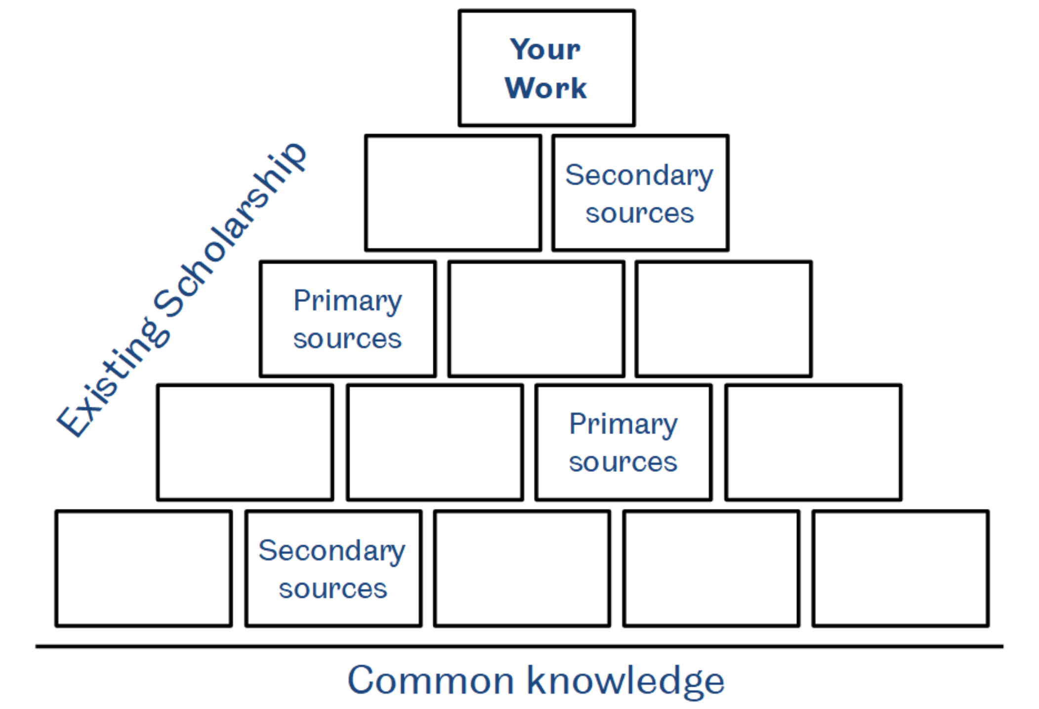

Image reproduced with permission from [301 Academic Skills Centre](https://www.sheffield.ac.uk/ssid/301" \o "301 Academic Skills Centre).

[Back to Contents](#_Contents" \o "Back to Contents)

## Structuring your work

Most academic writing from literature reviews to essays and dissertations take the form of an hourglass.

* Start broad to show the context and draw in your reader
* Focus in to provide an in-depth exploration of the topic and/or answer the essay question.
* Finish broad to explore the implication and broader impact of your work.

Back to Contents

## Introductions

### Grabbing attention

There are a few common ways to get off to a strong start and grab your reader’s attention in a piece of academic writing. For example, you could use:

* A big or surprising **fact** or **statistic** to demonstrate the importance of a topic, e.g. *Facebook is the biggest social media platform with 2.2 billion users worldwide.*
* A **significant quote** from a relevant figure or commentator, e.g. *‘By giving people the power to share, we’re making the world more transparent’ (Zuckerberg 2012).*
* A **rhetorical question** to encourage the reader to consider their own perspective on the topic, e.g. *Are you confident about the privacy of your online identity?*
* A **statement** of the **urgency** and/or current **significance** of the issue, e.g. *There is growing interest in the ethical responsibility of platforms such as Facebook to offer safeguards to protect the digital data of their users.*

### Claims

Most pieces of writing will be built around a central claim. This forms the core of the argument that you intend to get across to your reader and should be clear and bold (i.e. worth arguing about). Consider these examples:

* *Facebook is the biggest social media platform with 2.2 billion users worldwide.* – This is a **fact**, which can be easily verified and is unlikely to form the basis of a strong argument.
* *Enhanced data security information would change the behaviour of Facebook’s users.* – This is a **theory**, which could be put to the test through an experimental study.
* *Facebook’s uses and misuses of its data undermine the rights of its users’ online privacy.* – This is a **claim**, which is bold and exciting. It would make a good basis for the development of an academic argument.

### Mission statements

Your claim can be used as part of a mission statement. This is usually the final sentence of your introduction and summarises for the reader exactly what your piece of writing is going to be about. Our complete introduction might look something like this:

**Broad opening statement(s)** –Facebook is the biggest social media platform with 2.2 billion users worldwide. There is growing interest in the ethical responsibility of platforms such as Facebook to offer safeguards to protect the digital data of their users.

**Context/explanation** –Facebook has come under recent scrutiny for its practices relating to the sharing of user data with third party platforms and the subsequent (mis)uses of that data for commercial purposes.

**Mission statement** – This essay explores the issues of data security on Facebook and other platforms to suggest that our data can be used in ways that undermine our rights to online privacy.

[Back to Contents](#_Contents" \o "Back to Contents)

## Using evidence

### Information sources

Once you have made a claim, you will need to back it up with evidence. It goes without saying, but some forms of evidence can be stronger than others. If you haven’t already, you can consider the strengths and weaknesses of different sources by completing our [Know Your Information Sources](https://vle.shef.ac.uk/bbcswebdav/xid-47984380_1" \o "Know Your Information Sources activity) activity.

### Critical analysis

It is important when using evidence in your work to go beyond description to engage critically with sources. Critical analysis is what demonstrates your understanding and interpretation of the evidence to your reader. If you haven’t already, you can find out how to question and evaluate the information you are using by using our [Questioning and Evaluating Information worksheet](https://vle.shef.ac.uk/bbcswebdav/xid-47980908_1" \o "Questioning and Evaluating Information worksheet).

### Language

When reporting on sources it is important to be attentive to the use of your language. Using reporting verbs accurately to avoid overstating or understating the strength of evidence will help you formulate a balanced argument. Consider these examples:

* *Reid (2018) argues that…* – This example implies **uncertainty**.Other neutral terms include ‘suggest’, ‘report’, ‘state’.
* *Recent research demonstrates that…* – This example implies **agreement**. Other positive words include ‘reveal’, ‘show’, ‘prove’.
* *Zuckerberg claims that…* – This example implies **disagreement**. Other reporting words with more negative connotations include ‘allege’, ‘assert’.

[Back to Contents](#_Contents" \o "Back to Contents)

## Creating your conclusion

A strong conclusion is important to close your essay on a high. This will often involve looking more broadly at the implications of your work. What was the point of it and where might it lead next? There are several common strategies for concluding an academic piece of writing.

* **Is further research required?** –*Further work remains to be carried out to determine the extent to which data was misused by third-party applications.*
* **Are there any recommendations of practical applications?** –*In light of these findings, it would be beneficial to develop clearer and more accessible data security information to users and to develop new regulatory frameworks to restrict the sharing of data.*
* **What are the likely consequences?** –*In the absence of these safeguards, it is likely that there will be further breaches of user privacy across social media platforms.*

### Example conclusion

A well-structured conclusion will also reinforce the points made throughout your essay by rephrasing your mission statement and summarising your argument. So we might end up with a conclusion that looks like this:

**Rephrased mission statement** –This essay has explored the issues of data security on Facebook to suggest that our data can be used in ways that undermine our rights to digital privacy.

**Summary** – Recent media reports and statements from whistle-blowers working for both Facebook and third-party applications have been analysed to evaluate the extent of data breaches and subsequent misuses of data.

**Implications** – In light of these findings, it would be beneficial to develop clearer and more accessible data security information to users and to develop new regulatory frameworks to restrict the sharing of user data.

[Back to Contents](#_Contents" \o "Back to Contents)

## Recap

We have looked at an hourglass model for structuring your writing and have worked through an example model essay.

* Start broad to show the context and draw your reader in.
* Focus in to provide an in-depth exploration of the topic and/or answer the essay question.
* Finish broad to explore the implications and broader impact of your work.

However, it’s worth remembering that there is more than one correct way to write an academic piece of work and creating is also about playing with the conventions to find your own voice and style.

Back to Contents

## Summary

You have reached the end of this resource. This information has been adapted from the [Academic writing tutorial](https://vle.shef.ac.uk/bbcswebdav/xid-47983000_1).

See our other [Research Skills and Critical Thinking Tutorials for school and college students](https://www.sheffield.ac.uk/library/study/schoolsandcolleges).

See our other [Research Skills and Critical Thinking Tutorials for apprentices](https://www.sheffield.ac.uk/library/study/apprentices).

Visit our FAQs: [Library FAQs](http://libraryhelp.shef.ac.uk/)

Get in touch: [library@sheffield.ac.uk](mailto:library@sheffield.ac.uk)

[Back to Contents](#_Contents" \o "Back to Contents)

## Full URLs

301 Academic Skills Centre: <https://www.sheffield.ac.uk/academic-skills>

Harvard referencing guide: <https://librarydevelopment.group.shef.ac.uk/preentry/harvard.html>

Know your information sources activity: <https://vle.shef.ac.uk/bbcswebdav/xid-47984380_1>

Questioning and evaluating information worksheet:

<https://vle.shef.ac.uk/bbcswebdav/xid-47980908_1>

Academic writing tutorial: <https://vle.shef.ac.uk/bbcswebdav/xid-47983000_1>

Research Skills and Critical Thinking Tutorials for school and college students: <https://www.sheffield.ac.uk/library/study/schoolsandcolleges>

Research Skills and Critical Thinking Tutorials for apprentices: <https://www.sheffield.ac.uk/library/study/apprentices>

Library FAQs: <https://libraryhelp.shef.ac.uk/>

Back to Contents

Last reviewed: September 2024

Review due: Summer 2025



Except otherwise noted, this work by The University of Sheffield Library is licensed under the Creative Commons Attribution-NonCommercialShareAlike 4.0 International License. To view a copy of this license, visit http://creativecommons.org/licenses/by-nc-sa/4.0/.