# Producing a literature review

## Contents

Contents 1

What is a literature review? 2

Stages of a literature review 2

Stage 1: Planning your search 2

Developing a search strategy 3

Stage 2: Searching 3

What are academic databases? 3

Why use academic databases? 4

Discovering useful databases 4

Database video guides 5

The citation trail 5

Following the citation trail 6

Save your search query and set up alerts 6

Stage 3: Working with your search results 7

Organising and referencing your results 7

Reference management software 7

Questioning and evaluating your results 7

Questioning the item 8

Questioning the content 8

Questioning the author 9

Questioning the currency 9

Analysing your results 9

Stage 4: Writing 10

Further support for academic writing 10

Summary 10

Full URLs 11

Credits 12

## What is a literature review?

A **literature review** aims to give an overview of the current scholarly understanding of a particular topic, including any competing theories or perspectives.

In some disciplines, a literature review may be used to identify current key evidence and then analyse it to reach new conclusions.

Aims of a literature review

A literature review has **four** main aims:

1. Obtain an overview of the most current understanding of a particular topic.
2. Identify, critically evaluate and summarise key theories, approaches, evidence or data.
3. Provide background and context for your own research.
4. Draw conclusions from the available information and identify areas requiring further research.

Back to Contents

## Stages of a literature review

You can think of a literature review as a process, made up of **four stages** which you may need to repeat or refine more than once.

1. **Planning your search**: turning your question into a search strategy.
2. **Searching**: finding the most relevant information.
3. **Working with your search results**: organising, referencing, and evaluating the research.
4. **Writing**: writing your literature review in a critical academic style.

Back to Contents

## Stage 1: Planning your search

This section will focus on turning your **question** or **topic** into a **search strategy** and it will cover:

* Identifying your **search terms**.
* “**Phrase searching**”.
* Identifying **alternative** **terms**.
* **Combining** your search terms.

### Developing a search strategy

Click on the link below to access the online tutorial. When you have finished, return to this document to continue with the tutorial.

[Developing a search strategy tutorial](https://librarydevelopment.group.shef.ac.uk/storyline/discovering/developing-search-strategy/story_html5.html)

Back to Contents

## Stage 2: Searching

This section will focus on how to search for relevant information and it will cover:

* What **academic databases** are and the advantages of using them.
* How to discover and use **academic databases**.
* **Using citations** to discover related research to your topic.
* **Saving your searches** and setting up alerts in Scopus and Web of Science.

Back to Contents

### What are academic databases?

Academic databases are online search tools which are designed to help you explore scholarly literature. They index a wide range of research publications, allowing you to run comprehensive searches of journal articles, conference papers, book chapters and more, **all from one place**.

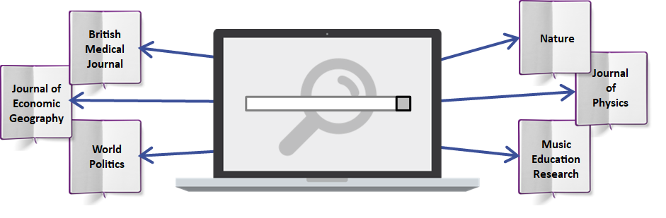

[Book icon](https://pixabay.com/photos/a-book-isolated-open-book-empty-3246186/) by [Darkmoon_Art](https://pixabay.com/users/darkworkx-1664300/) licensed under [Pixabay License](https://pixabay.com/service/license/) from [Pixabay](https://pixabay.com/)

[Laptop image](https://www.freepik.com/free-vector/technological-devices-design_953322.htm#page=1&query=device&position=1) by [d3images](https://www.freepik.com/d3images) licensed under [Freepik License](https://www.freepikcompany.com/legal) from [Freepik](https://www.freepik.com/)

[Magnifier icon](https://www.iconfinder.com/icons/111124/search_find_zoom_icon) by [WPZOOM](https://www.iconfinder.com/iconsets/wpzoom-developer-icon-set) licensed under [CC BY-SA 3.0](https://creativecommons.org/licenses/by-sa/3.0/) from [Iconfinder](https://www.iconfinder.com/)

Search tools like [StarPlus](https://find.shef.ac.uk/) are useful for running quick, simple searches, but for a literature review it is a good idea to use academic databases.

Back to Contents

### Why use academic databases?

Below are some of the reasons why it is useful to use academic databases for a literature review:

1. **In-depth coverage**: Run comprehensive searches on a wide range of scholarly literature.
2. **Advanced search**: Use the advanced search features to carry out focussed searches.
3. **Academic credibility**: Discover credible resources as most academic databases index peer-reviewed scholarly materials.
4. **Make connections**: Follow citations and other connections between articles to help you evaluate what you find and discover related content.
5. **Sort and Refine**: Take advantage of useful features for managing and organising your search results.
6. **Save and export**: Save your searches so you can run them again in the future, or export your search results.

Back to Contents

### Discovering useful databases

The University Library provides access to many academic databases with each one indexing a different range of material.

Some databases are subject-specific and some cover a range of subject areas.

To ensure you are not missing any key research for your literature review, it is often a good idea to use more than one database.

Useful multidisciplinary databases for most subjects are [**Scopus**](https://www.sheffield.ac.uk/library/cdfiles/scopus) and [**Web of Science**](https://www.sheffield.ac.uk/library/cdfiles/wos).

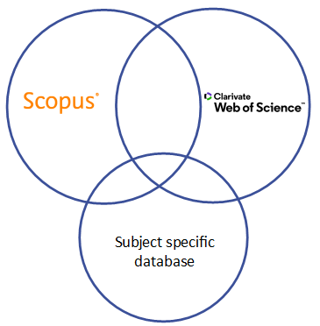

Scopus and Web of Science logos used with permission.

To identify useful databases for your subject, see the **Discovering** tab in the [**Library Subject Guide**](https://sheffield.libguides.com/?b=g&d=a) for your department.

Back to Contents

### Database video guides

Click on the links below to watch the Library video guides on how to use **Scopus** and **Web of Science**.

[Using Scopus video guide](https://digitalmedia.sheffield.ac.uk/media/Using+Scopus/1_h1sx7drj)

[Using Web of Science video guide](https://digitalmedia.sheffield.ac.uk/media/Using+Web+of+Science/1_22hds7ym)

See video guides for other databases: [Database guides - Research Skills and Critical Thinking Tutorials](https://www.sheffield.ac.uk/library/study/research-skills/database-guides).

Back to Contents

### The citation trail

Research is an **iterative** process - each piece of research builds upon work that came before it, and will itself influence future research that comes afterwards.

Researchers acknowledge the influence of other people by citing their work. You can use this **citation network** to trace the influence of ideas through the literature.

Most academic databases give the option to follow the citation trail **forwards** and **backwards** in time. This can be a useful way to find other articles on a similar topic.

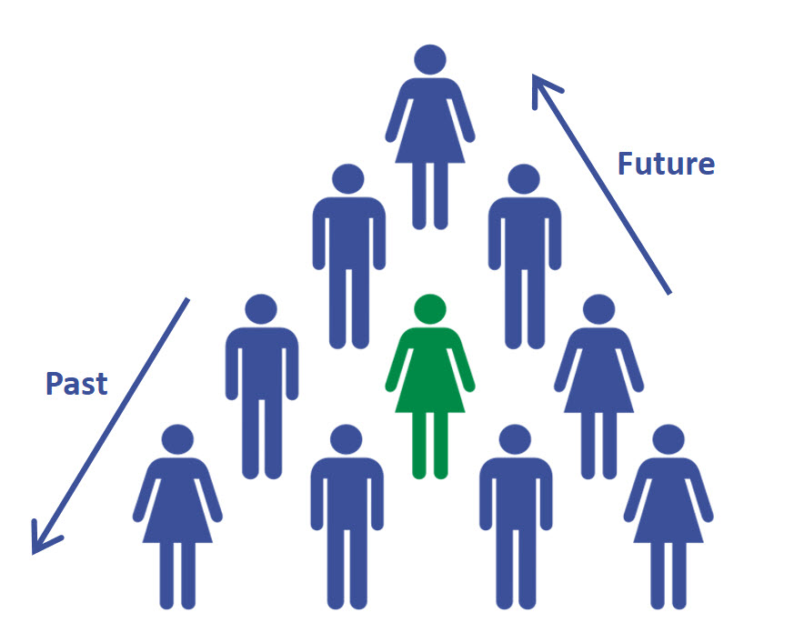

[Team building](https://thenounproject.com/search/?q=team%20building&i=209648) (adapted) by [Ian Kirkland](https://thenounproject.com/ianthekirkland/) licensed under [CC BY 3.0](https://creativecommons.org/licenses/by/3.0/) from the [Noun Project](https://thenounproject.com/)

Back to Contents

## Following the citation trail

Web of Science and Scopus **track any citations** between the research articles they index.

When you select a specific article, you can see the **citation network** of that article. This includes:

* articles that the author has cited and referenced.
* articles that have cited and referenced the original article after publication.

For the **most recently published** articles, the number of citations will automatically be lower because they will not have had time to build up by being referenced in other articles.

**Click** on the links below to watch the Library video guides on how you can follow the citation trail and see related articles from your search results:

[Using citations in Scopus video guide](https://digitalmedia.sheffield.ac.uk/media/Using+Citations+in+Scopus/1_x0687rcr)

[Using citations in Web of Science video guide](https://digitalmedia.sheffield.ac.uk/media/Using+Citations+in+Web+of+Science/1_sqr4wqy7)

Back to Contents

### Save your search query and set up alerts

Most academic databases give you the option to **save your** **search query**, so that you can come back to it later. This is useful as it will pick up any new articles that have been added to the database since the last time you searched.

Once you are happy with your search terms and the results you are getting, it is a good idea to save your **final ‘best’ search**. This will help you keep track of the search terms and search query you have used.

You can also set up **email alerts** to notify you when new articles that match your search are added to the database.

**Click** on the links below to watch the Library video guides on how to save searches and set alerts:

[How to save search queries and set alerts in Scopus video guide](https://digitalmedia.sheffield.ac.uk/media/How+to+save+search+queries+and+set+alerts+in+Scopus/1_j6nu4p1x)

[How to save search queries and set alerts in Web of Science video guide](https://digitalmedia.sheffield.ac.uk/media/How+to+save+search+queries+and+set+alerts+in+Web+of+Science/1_vz79sacw)

Back to Contents

## Stage 3: Working with your search results

This section will focus on questioning and evaluating your results and using reference management software to help you organise your references.

It will cover:

* **Organising** and **referencing** your search results
* **Reference management software**.
* **Questioning** and **evaluating** your search results.

Back to Contents

### Organising and referencing your results

You are likely to have a large number of search results which you will need to manage and reference accurately.

It may be useful at this stage to consider how you will organise your results, for example **chronologically**, or by **theme**.

There are tools available to help you keep organised so you can write up your search process, remove duplicates, and reference your sources correctly.

To learn more about citing and referencing different sources, including departmental referencing style guides, see the [Library’s Referencing page](https://www.sheffield.ac.uk/library/study/research-skills/referencing).

Back to Contents

### Reference management software

Reference management software is really useful to help you save, organise and retrieve a large number of search results.

However, you will need to invest time learning how to use reference management software, as well as exporting, editing, and checking any references generated for accuracy and consistency.

There are several different types of reference managers available, but popular free ones are **Mendeley**, **Zotero**, and **Endnote Online**.

For guidance, see the [Library’s reference management page](https://www.sheffield.ac.uk/library/refmant).

Back to Contents

### Questioning and evaluating your results

**Analysing**, **evaluating**, **interpreting** and **thinking critically** about your results is an essential part of undertaking a literature review.

A literature review will require you to think critically about what you read and identify any gaps in the literature.

Your ability to appraise and evaluate the quality of academic research will grow as you read around your topic and develop your knowledge.

Using your own questioning mindset and the information available in academic databases to evaluate your search results, you can make an informed decision about the quality and reliability of the research you are using.

The following sections will suggest a series of questions that you may want to consider when evaluating your results.

Back to Contents

### Questioning the item

* Is it **relevant** to your topic? Check the abstract / introduction / conclusion. Is it **primary** (presenting original research), or **secondary** research (summarising research)?
* Is the information **peer-reviewed**?
* How much **attention** has the research received?
  + Metrics are quantitative measures designed to help evaluate research outputs by tracking attention received. For more information see [What are bibliometrics and altmetrics?](https://www.sheffield.ac.uk/library/research/metrics/intro)
* Where is it published? Is it a **reputable journal** and/or **publisher**?
  + **Metrics** can also help you to identify which journals receive more attention than others. See the ‘Comparing journals’ section of [Uses of bibliometrics and altmetrics](https://www.sheffield.ac.uk/library/research/metrics/what).

Back to Contents

### Questioning the content

* How does the information relate to the **topic**?
* Has the work been supported by **reputable research**?
* Are the **references** used appropriate?
* Are the **research methods** and **conclusions** valid/reliable?
* Are the conclusions in line with **other research** on the topic? If not, why not?

Back to Contents

### Questioning the author

* **What else** have they written?
* Are they **influential** in their field? Citations can give an indication of the influence or reputation of an author.
* Who are they **funded** by?
* Do they work for a particular **organisation**?

You can use **Web of Science** and **Scopus** to search for an author, learn more about their academic credentials, the subject area they work in, and explore the other articles they have written.

This may help you build a picture of the author’s research interests, their contribution to their field, and check to see if there have been more recent developments in the subject area.

Click on the links below to watch the Library video guides on how to assess an author’s impact:

[How to assess an author's influence in Scopus video guide](https://digitalmedia.sheffield.ac.uk/media/How+to+assess+an+author%27s+impact+in+Scopus/1_uv89j33d" \o "How to assess an author's impact in Scopus video guide)

[How to assess an author's influence in Web of Science video guide](https://digitalmedia.sheffield.ac.uk/media/How+to+assess+an+author%27s+impact+in+Web+of+Science/1_ln04pyrb)

Back to Contents

### Questioning the currency

* **When** was it published?
* How **current** is the information? The importance of this will vary by topic.
* Why has this information appeared **at this point in time**?
* Have more recent articles cited this research? Have they **reproduced**, **refuted** or **built upon** the original conclusions?

### Analysing your results

You can use the inbuilt functionality of some databases to analyse your results further. Click on the links below to see how Scopus and Web of Science do this, including analysis by author, institution, year of publication, country and subject area.

[Scopus Tutorial: How to analyze your search results](https://service.elsevier.com/app/answers/detail/a_id/35959/supporthub/scopus/)

[Web of Science: Steps to analyze results](https://support.clarivate.com/ScientificandAcademicResearch/s/article/Web-of-Science-Steps-to-analyze-results)

Back to Contents

## Stage 4: Writing

This section will focus on writing your literature review:

* Your review needs to have a **critical academic style**.
* Organise your review around **key themes** identified within the literature.
* **Plan carefully** to ensure that your review is structured in a logical way with clear links between sections.
* Support the statements you make with **examples** and **evidence** from your synthesis of the literature.
* Finally, ensure that you include your own **analysis** and explain how it relates to your own research.

Back to Contents

### Further support for academic writing

The University’s **301 Academic Skills Centre** deliver a workshop on Writing a Literature Review and provide guidance on academic writing including a digital workshop. Follow the links below to access them:

[301: Academic Skills Centre home](https://www.sheffield.ac.uk/academic-skills/study-skills-online)

[301: Writing a Literature Review workshop](https://students.sheffield.ac.uk/301/study-skills/workshops)

[301: Academic writing guidance](https://www.sheffield.ac.uk/academic-skills/study-skills-online/academic-writing)

[301: Academic writing digital workshop](https://xerte.shef.ac.uk/play.php?template_id=278)

Back to Contents

## Summary

You have reached the end of this resource. This information has been adapted from the [Producing a literature review tutorial](https://vle.shef.ac.uk/bbcswebdav/xid-48027136_1).

Why not look at some of our other Research Skills and Critical Thinking resources? [Book onto a Workshop or take an Online Tutorial.](https://www.sheffield.ac.uk/library/study/research-skills)

Remember to reflect on and record your skills development using [mySkills](https://www.sheffield.ac.uk/skills/myskills).

Visit our FAQs: [Library FAQs](http://libraryhelp.shef.ac.uk/)

Get in touch: [library@sheffield.ac.uk](mailto:library@sheffield.ac.uk)

[Back to Contents](#_Contents" \o "Back to Contents)

## Full URLs

Developing a search strategy tutorial: <https://vle.shef.ac.uk/bbcswebdav/xid-48024365_1>

Scopus: <https://www.sheffield.ac.uk/library/cdfiles/scopus>

Web of Science: <https://www.sheffield.ac.uk/library/cdfiles/wos>

Library Subject Guides: [https://sheffield.libguides.com/](https://sheffield.libguides.com/?b=g&d=a)

Using Scopus (video guide): <https://digitalmedia.sheffield.ac.uk/media/1_h1sx7drj>

Using Web of Science (video guide): <https://digitalmedia.sheffield.ac.uk/media/1_22hds7ym>

Library databases video guides: [https://www.sheffield.ac.uk/library/research-skills/databaseguides](https://www.sheffield.ac.uk/library/idlt/databaseguides)

Using Citations in Scopus (video guide):

<https://digitalmedia.sheffield.ac.uk/media/1_x0687rcr>

Using Citations in Web of Science (video guide):

<https://digitalmedia.sheffield.ac.uk/media/1_sqr4wqy7>

How to save search queries and set alerts in Scopus (video guide): <https://digitalmedia.sheffield.ac.uk/media/1_j6nu4p1x>

How to save search queries and set alerts in Web of Science (video guide): <https://digitalmedia.sheffield.ac.uk/media/1_vz79sacw>

Library referencing page: [https://www.sheffield.ac.uk/library/research-skills/referencing](https://www.sheffield.ac.uk/library/idlt/referencing)

Library reference management page: <https://www.sheffield.ac.uk/library/refmant>

What are bibliometrics & altmetrics? <https://www.sheffield.ac.uk/library/research/metrics/intro>

Uses of bibliometrics & altmetrics: <https://www.sheffield.ac.uk/library/research/metrics/what>

How to assess an author's influence in Scopus (video guide): <https://digitalmedia.sheffield.ac.uk/media/1_uv89j33d>

How to assess an author's influence in Web of Science (video guide): <https://digitalmedia.sheffield.ac.uk/media/1_ln04pyrb>

Scopus Tutorial: How to analyze your search results: <https://service.elsevier.com/app/answers/detail/a_id/35959/supporthub/scopus/>

Web of Science: Steps to analyze results: <https://support.clarivate.com/ScientificandAcademicResearch/s/article/Web-of-Science-Steps-to-analyze-results>

301 Academic Skills Centre: <https://www.sheffield.ac.uk/academic-skills/study-skills-online>

301 Academic Skills Centre workshops: <https://students.sheffield.ac.uk/301/study-skills/workshops>

301 Academic Skills Centre Guidance on Academic Writing: <https://www.sheffield.ac.uk/academic-skills/study-skills-online/academic-writing>

301 Academic Skills Centre Digital Workshop on Academic Writing: <https://xerte.shef.ac.uk/play.php?template_id=278>

Producing a literature review tutorial: <https://vle.shef.ac.uk/bbcswebdav/xid-48027136_1>

Research Skills and Critical Thinking Workshops and Tutorials: <https://www.sheffield.ac.uk/library/study/research-skills>

mySkills: <https://www.sheffield.ac.uk/skills/myskills>

Library FAQs: <https://libraryhelp.shef.ac.uk/>

University Library’s referencing page: <https://www.sheffield.ac.uk/library/study/research-skills/referencing>

### Credits

Book icon: <https://pixabay.com/photos/book-isolated-open-book-empty-3246186/>

Darkmoon_Art: <https://pixabay.com/users/darkworkx-1664300/>

Pixabay License: <https://pixabay.com/service/license/>

Pixabay: <https://pixabay.com/>

Laptop image: <https://www.freepik.com/free-vector/technological-devices-design_953322.htm#page=1&query=device&position=1>

d3images: <https://www.freepik.com/d3images>

Freepik License: <https://www.freepikcompany.com/legal>

Freepik: <https://www.freepik.com/>

Magnifier icon: <https://www.iconfinder.com/icons/111124/find_search_zoom_icon>

WPZOOM: <https://www.iconfinder.com/iconsets/wpzoom-developer-icon-set>

CC BY-SA 3.0: <https://creativecommons.org/licenses/by-sa/3.0/>

Iconfinder: <https://www.iconfinder.com/>

Team building: <https://thenounproject.com/search/?q=team%20building&i=209648>

Ian Kirkland: <https://thenounproject.com/ianthekirkland/>

CC BY 3.0: <https://creativecommons.org/licenses/by/3.0/>

Noun Project: <https://thenounproject.com/>

External link icon: <https://www.flaticon.com/free-icon/external-link-symbol_25284>

Dave Gandy: <https://www.flaticon.com/authors/dave-gandy>

CC BY 3.0: <https://creativecommons.org/licenses/by/3.0/>

Flaticon: <https://www.flaticon.com/>

Back to Contents

Last reviewed: September 2024

Review due: Summer 2025



Except otherwise noted, this work by The University of Sheffield Library is licensed under the Creative Commons Attribution-NonCommercialShareAlike 4.0 International License. To view a copy of this license, visit http://creativecommons.org/licenses/by-nc-sa/4.0/.