Introduction to Infographics

Contents
Introduction to Infographics 1
Contents 1
Introduction 2
What is an Infographic? 2
Infographic Best Practice 2
The Anatomy of an Infographic 3
Types of Infographics 4
Chart: to present statistics, facts and figures 4
List: with a focus on text 6
Timeline: to present development over a period 9
Flowchart: to explain stages of a process 11
Comparison: to contrast and compare data 13
Location: maps with colour coded areas 15
Hierarchical: to present data according to levels 17
Visualised numbers: to add visual interest to numbers 19
Creating Infographics: The Process 21
Digital Tools for Creating Infographics 21
Visme 21
Piktochart 21
Summary 22
References 22
Full URLs 22

Introduction
By the end of this tutorial you will be able to:
- Define the term infographic.
- Understand different types of infographics.
- Create an effective infographic using a digital tool.
Back to contents

What is an Infographic?
Information + Graphics = Infographics.
“A visual representation of information or data, for example as a chart or diagram: a good infographic is worth a thousand words.” (Oxford Dictionary of English, 2015)
The human brain is very well adapted to processing visual information.
This makes data visualisations and infographics very powerful tools for communicating lots of information in an easily digestible format.
You don’t need to be a graphic designer or an artist to make effective infographics - there are lots of free online tools available to help you.
Back to contents

Infographic Best Practice
The mark of a good infographic is its effectiveness in communicating a message concisely and quickly.
David McCandless (2010) – data journalist and information designer - describes this as “knowledge compression”.
- See his website: Information is beautiful.
- Watch his TED talk: The beauty of data visualization.
- Read his book (2009) Information is beautiful.
Back to contents

The Anatomy of an Infographic
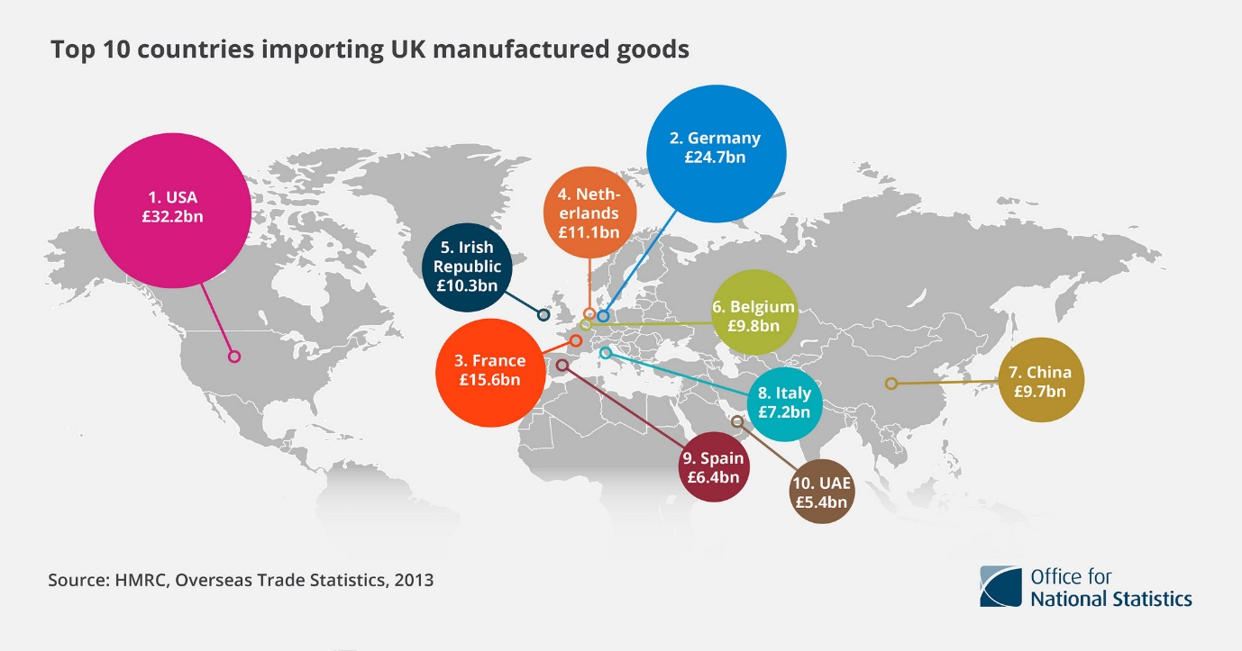
Top 10 countries importing UK manufactured goods by Office for National Statistics used under CC BY 2.0
- Focused title with a key message that narrates a story worth telling.
- Simple but visually appealing design; brightly-coloured circles help convey the key message.
- Accurate and well-researched data.
- Produced by a reputable source.
Back to contents

Types of Infographics

Chart: to present statistics, facts and figures
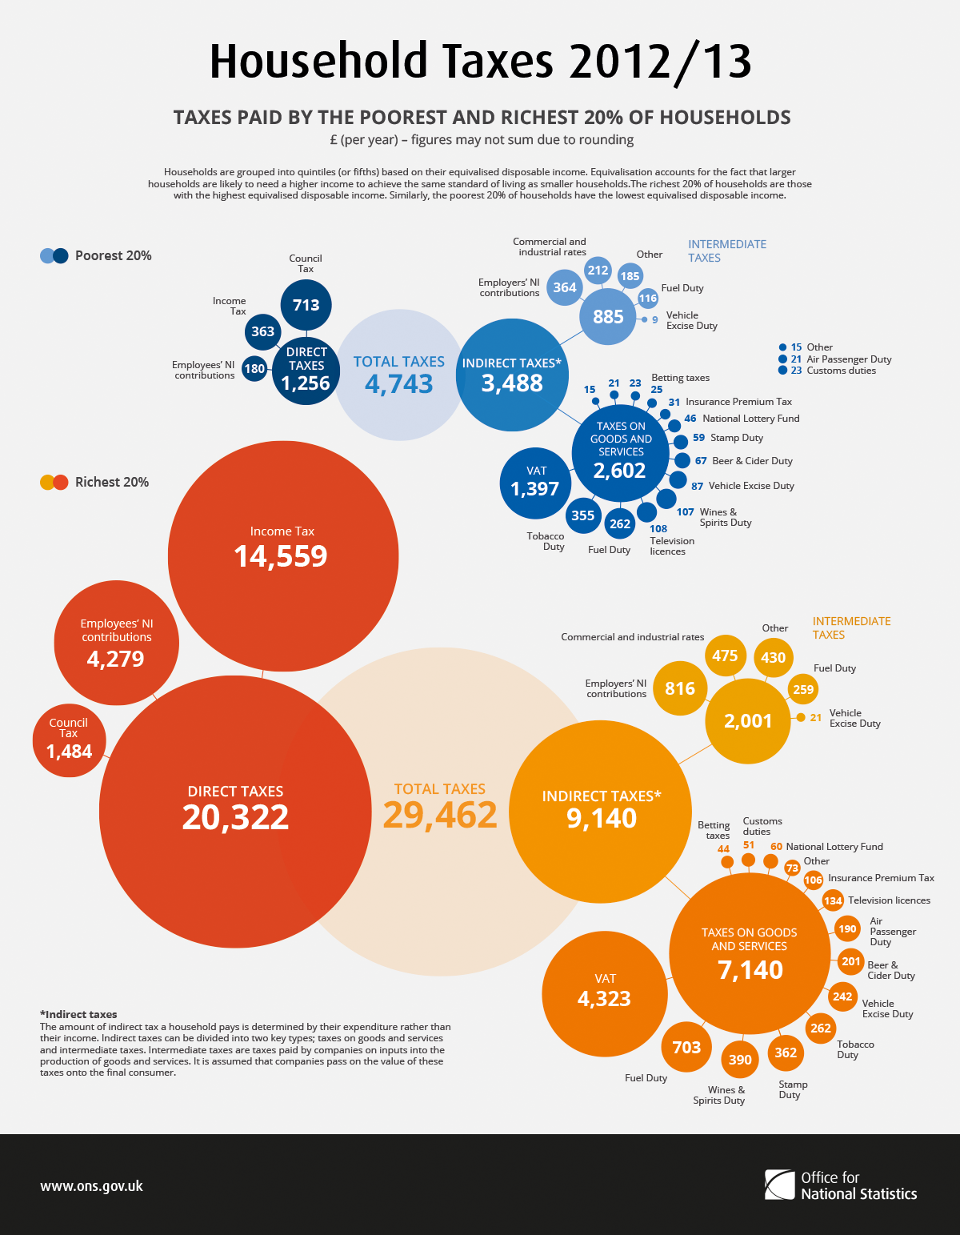
Household Taxes, 2012/13 by Office for National Statistics used under CC BY 2.0
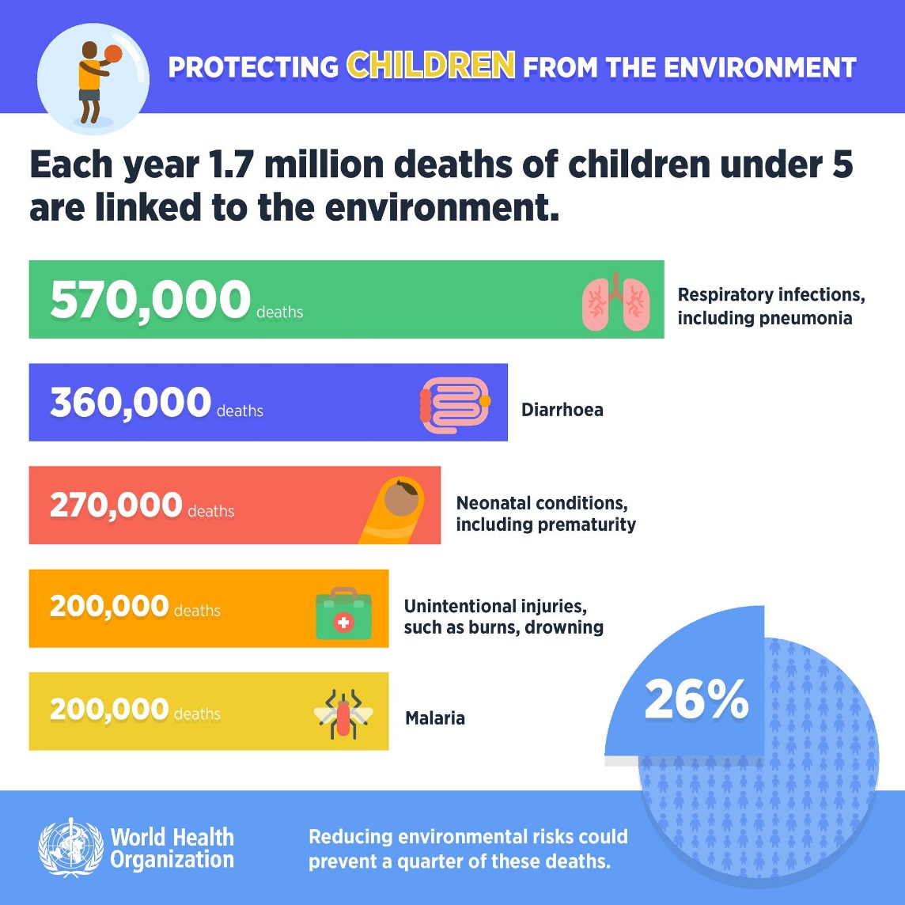
Children's Deaths linked to the Environment by DES Daughter used under CC BY-NC-SA 2.0
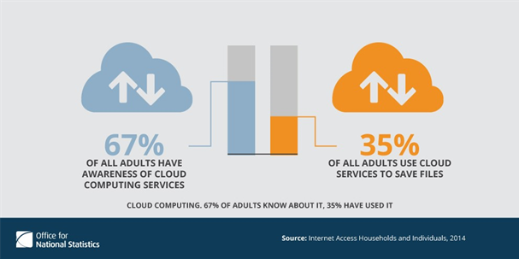
Cloud computing by Office for National Statistics used under CC BY-NC-ND 2.0
Back to contents

List: with a focus on text
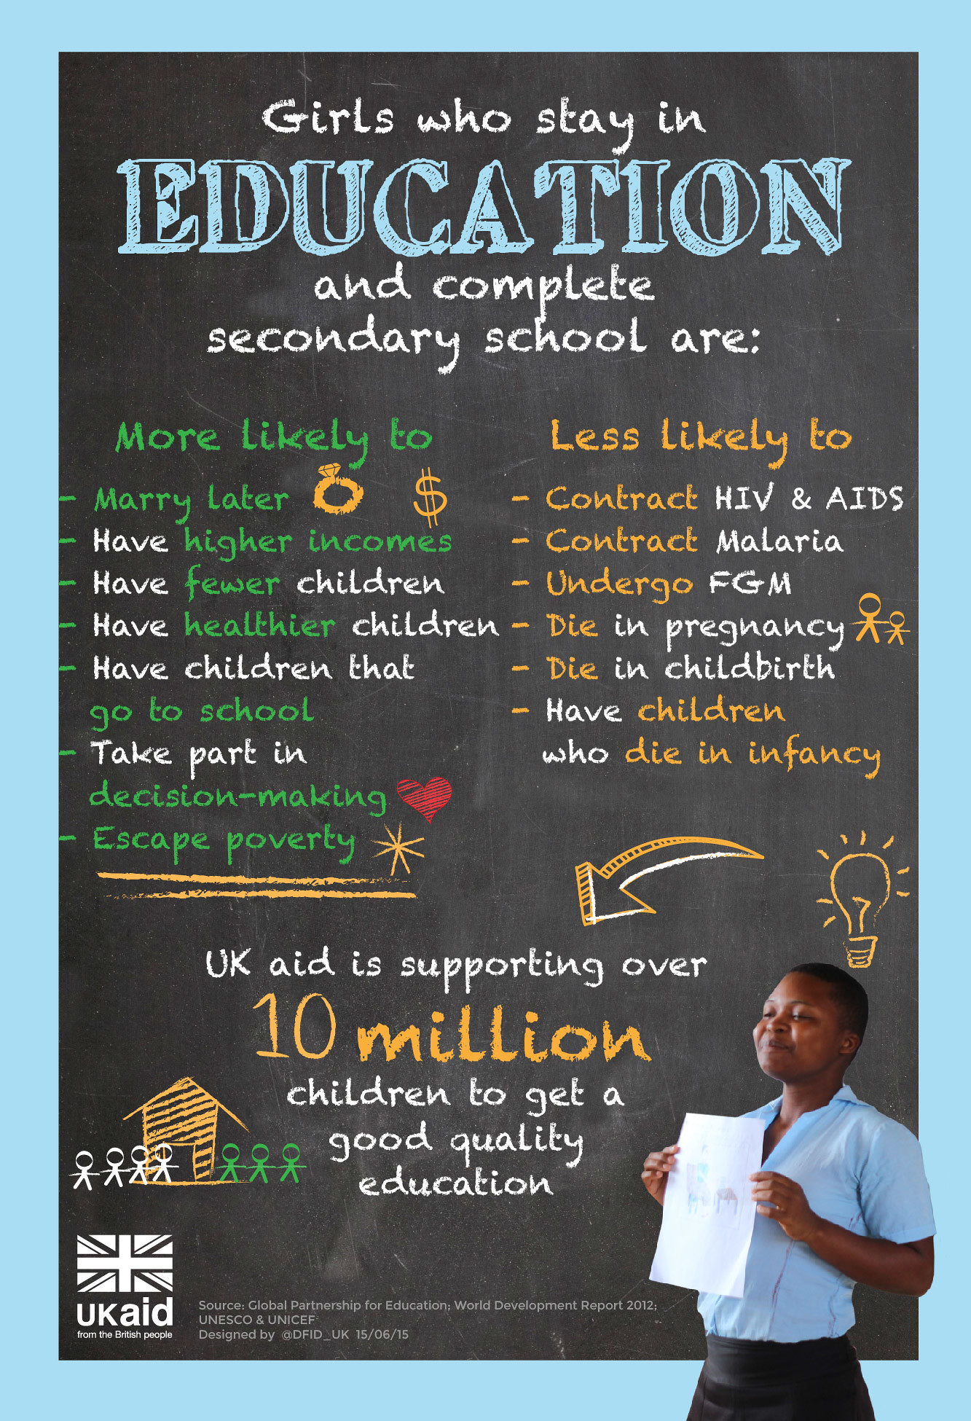
Girls Education Infographic by UKaid used under CC BY 2.0

Self-Care by Pain Pix used under CC BY 2.0
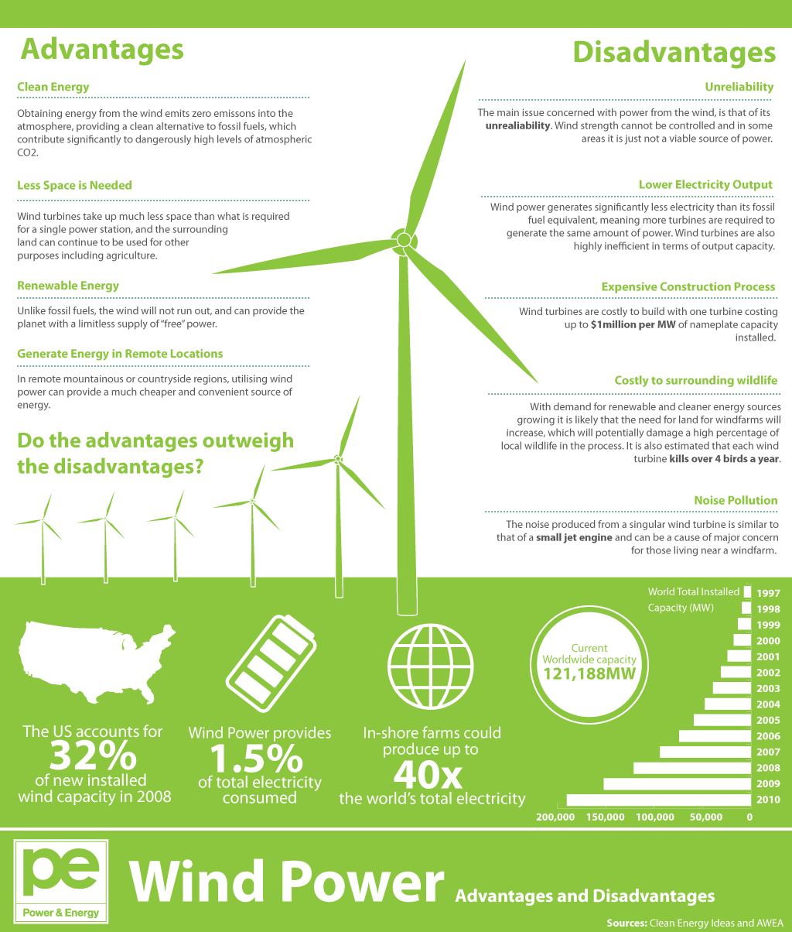
Advantages and Disadvantages of Wind Power by GDS Infographics used under CC BY 2.0
Back to contents

Timeline: to present development over a period
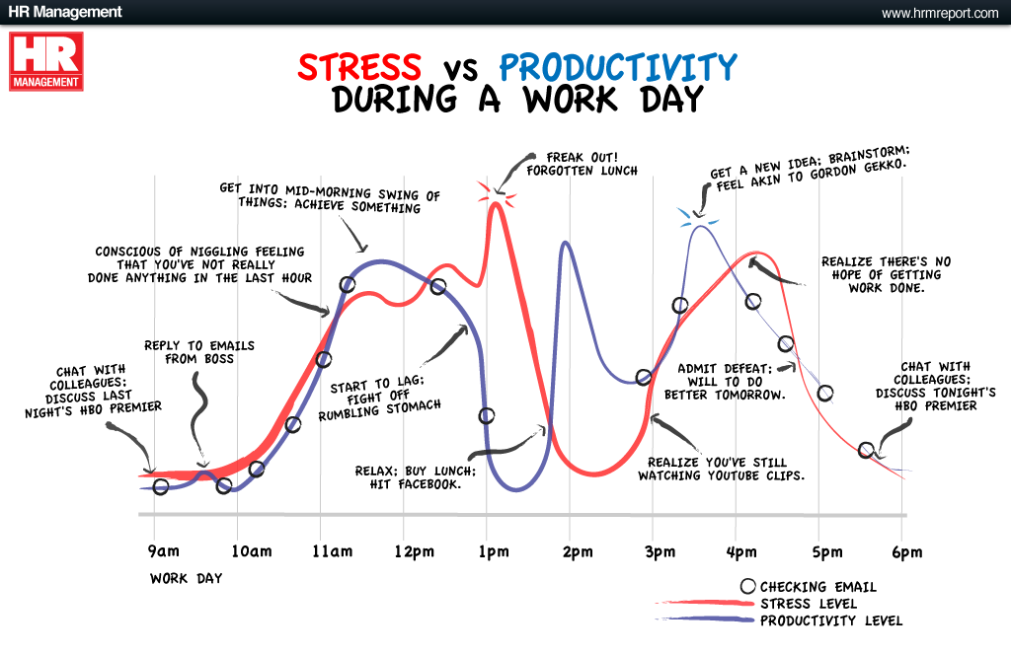
Stress vs Productivity by GDS Infographics used under CC BY 2.0
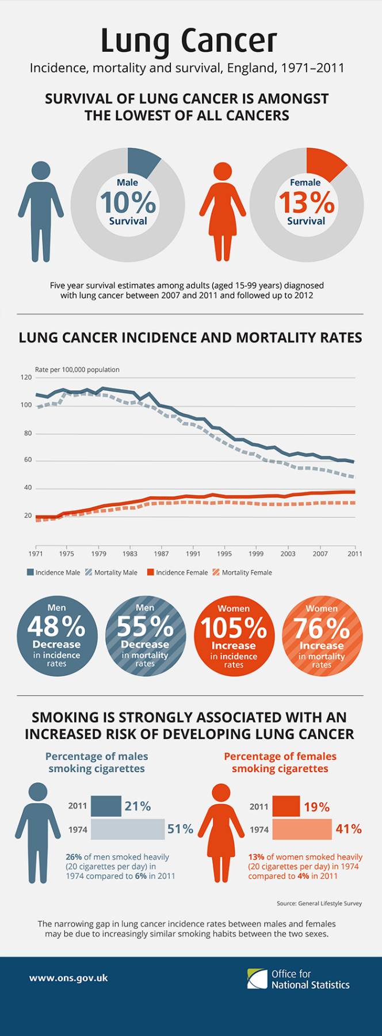
Lung cancer 1971-2011 by Office for National Statistics used under CC BY 2.0
Back to contents

Flowchart: to explain stages of a process
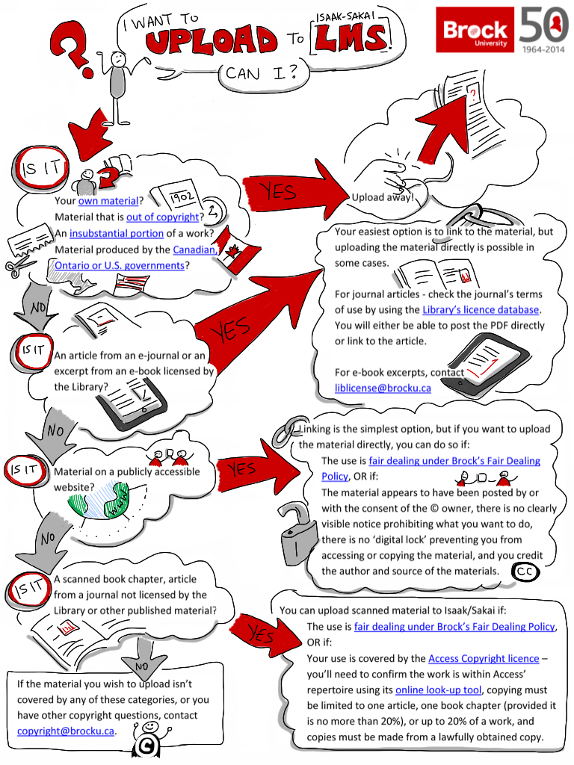
Can I upload by Giulia Forsythe used under CC BY-NC-SA 2.0
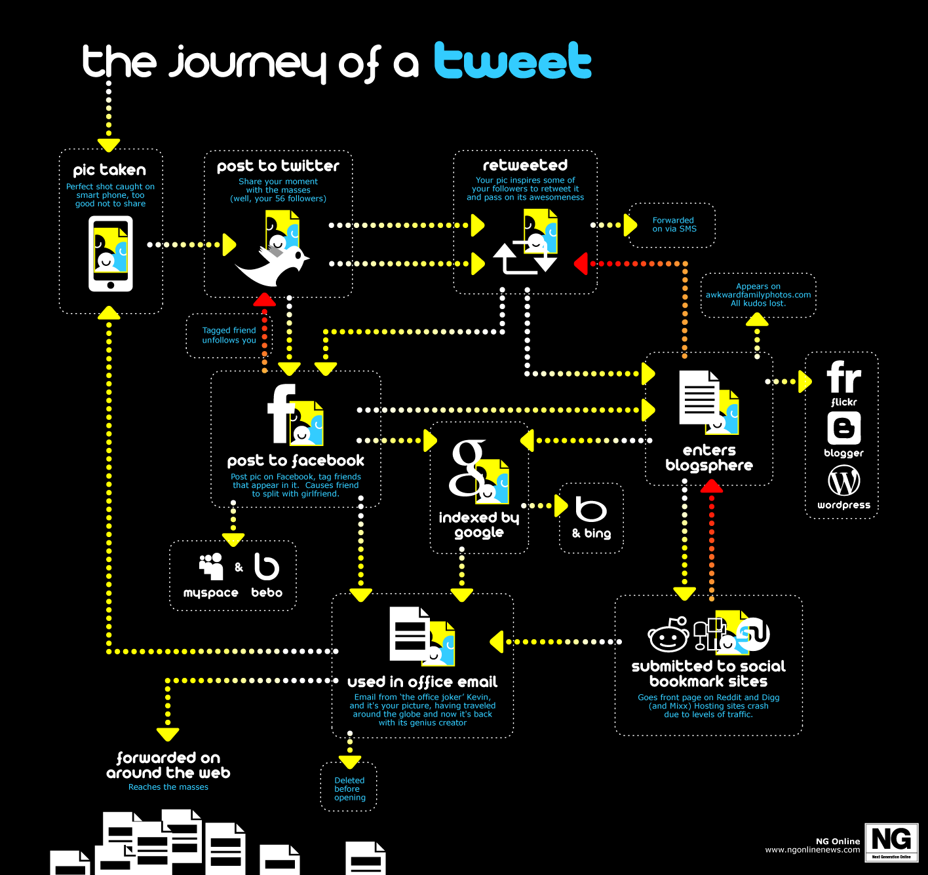
The journey of tweet by GDS Infographics used under CC BY 2.0
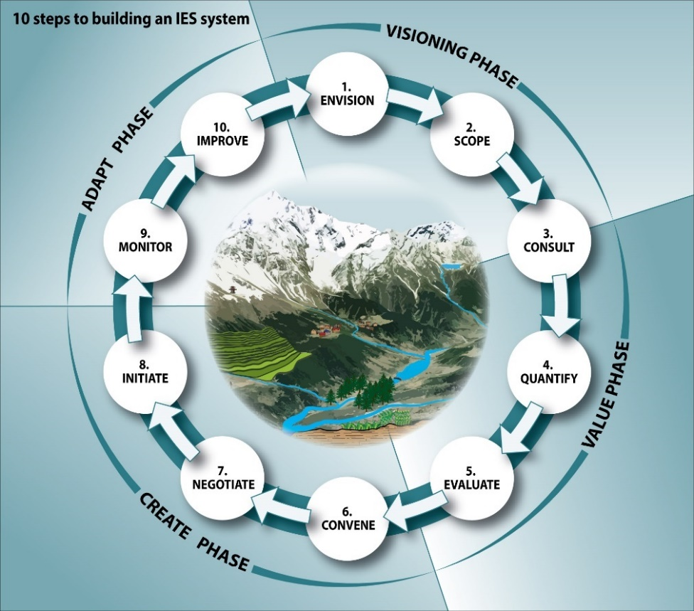
Ten steps to building an IES system by GRID Arendal used under CC BY-NC-SA 2.0
Back to contents

Comparison: to contrast and compare data
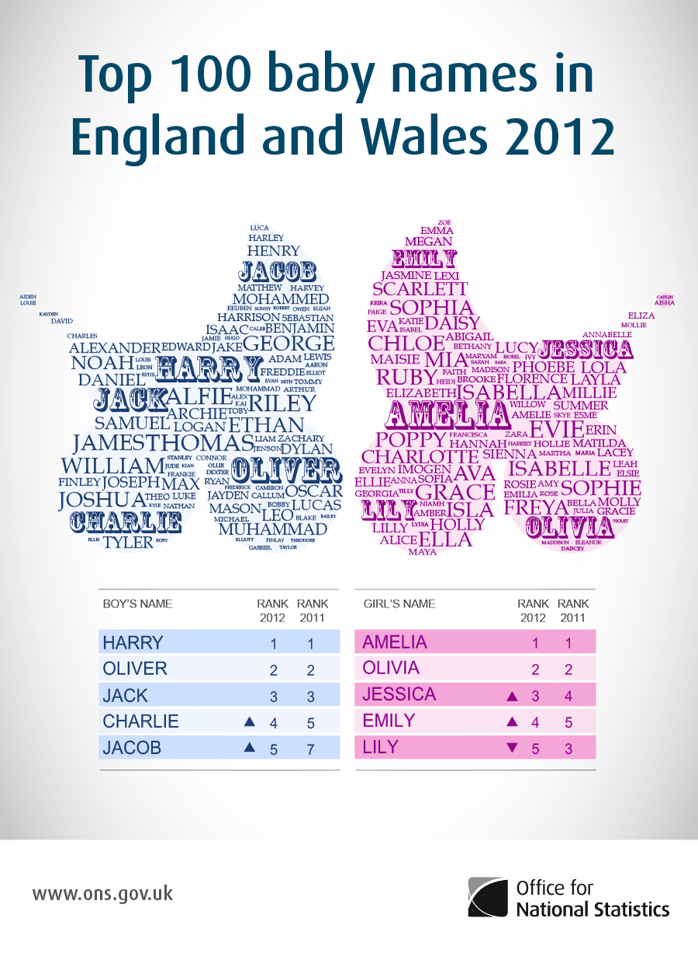
Top Baby Names by Office for national Statistics used under CC BY 2.0
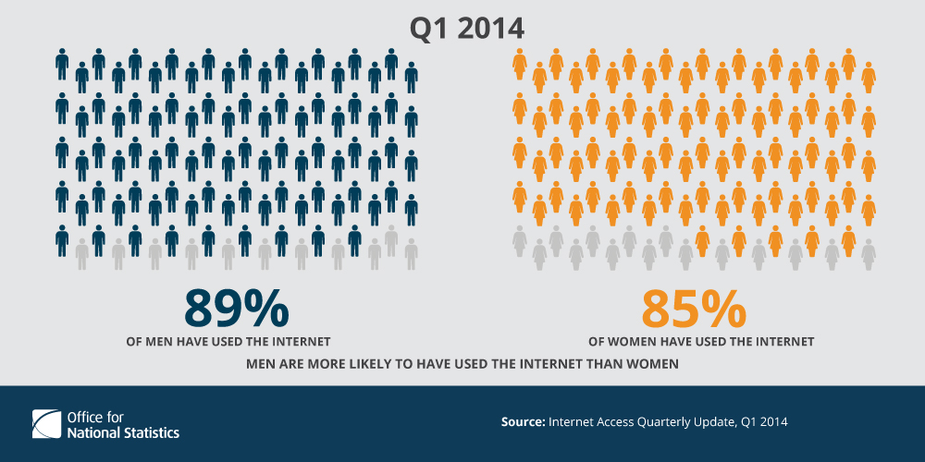
Internet Usage by Office for National Statistics used under CC BY-NC-ND 2.0
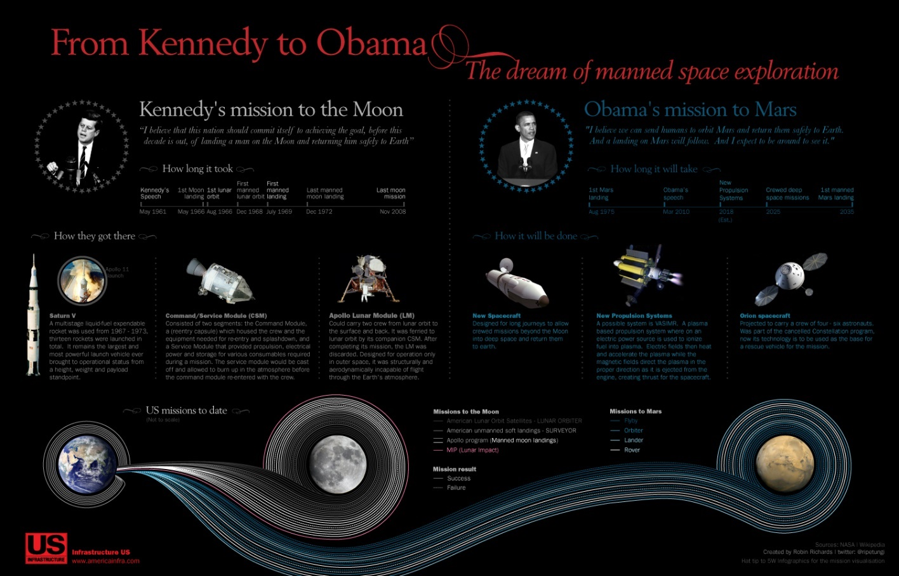
Mars Mission by GDS Infographics used under CC BY 2.0
Back to contents

Location: maps with colour coded areas
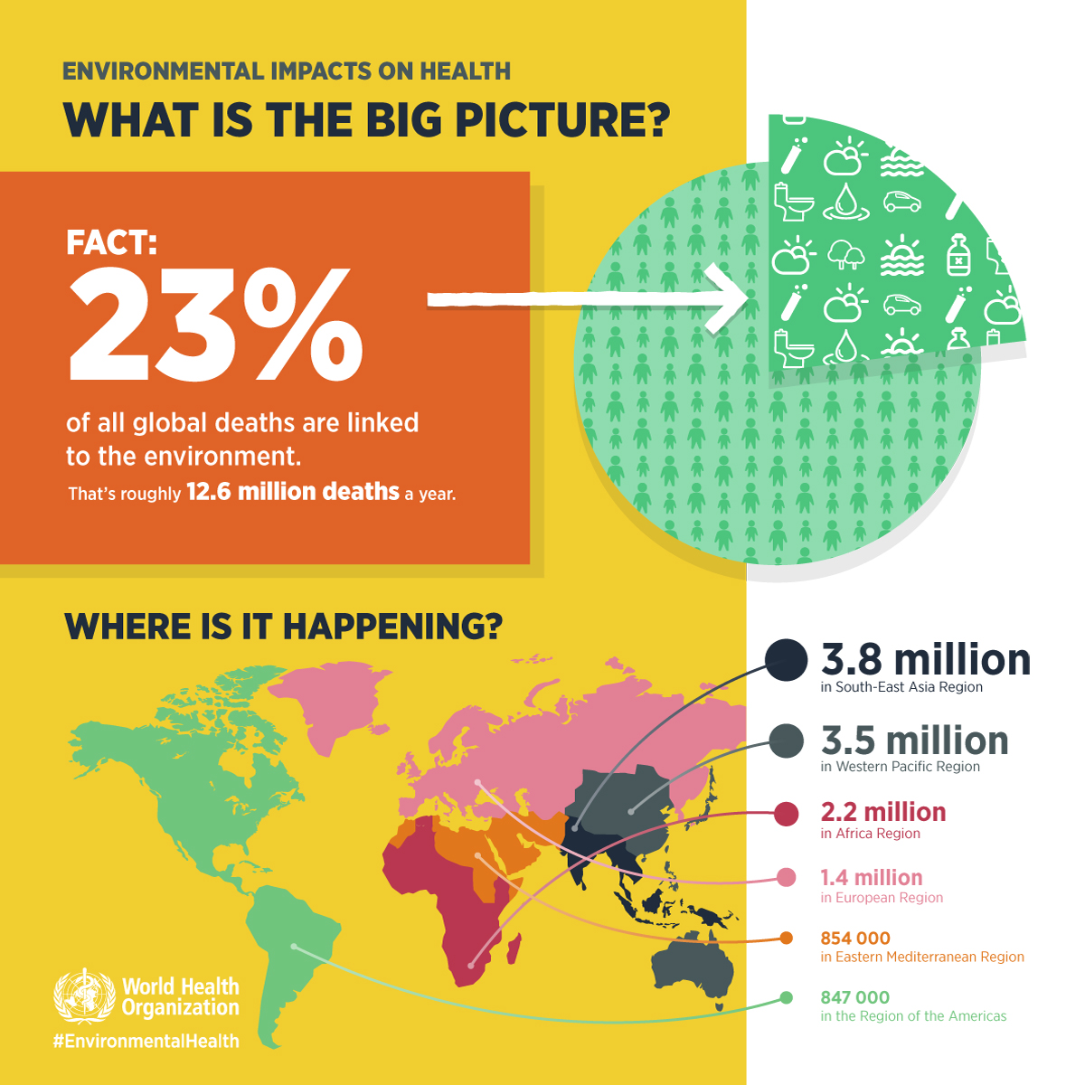
What is the big picture? by DES Daughter used under CC BY-NC-SA 2.0
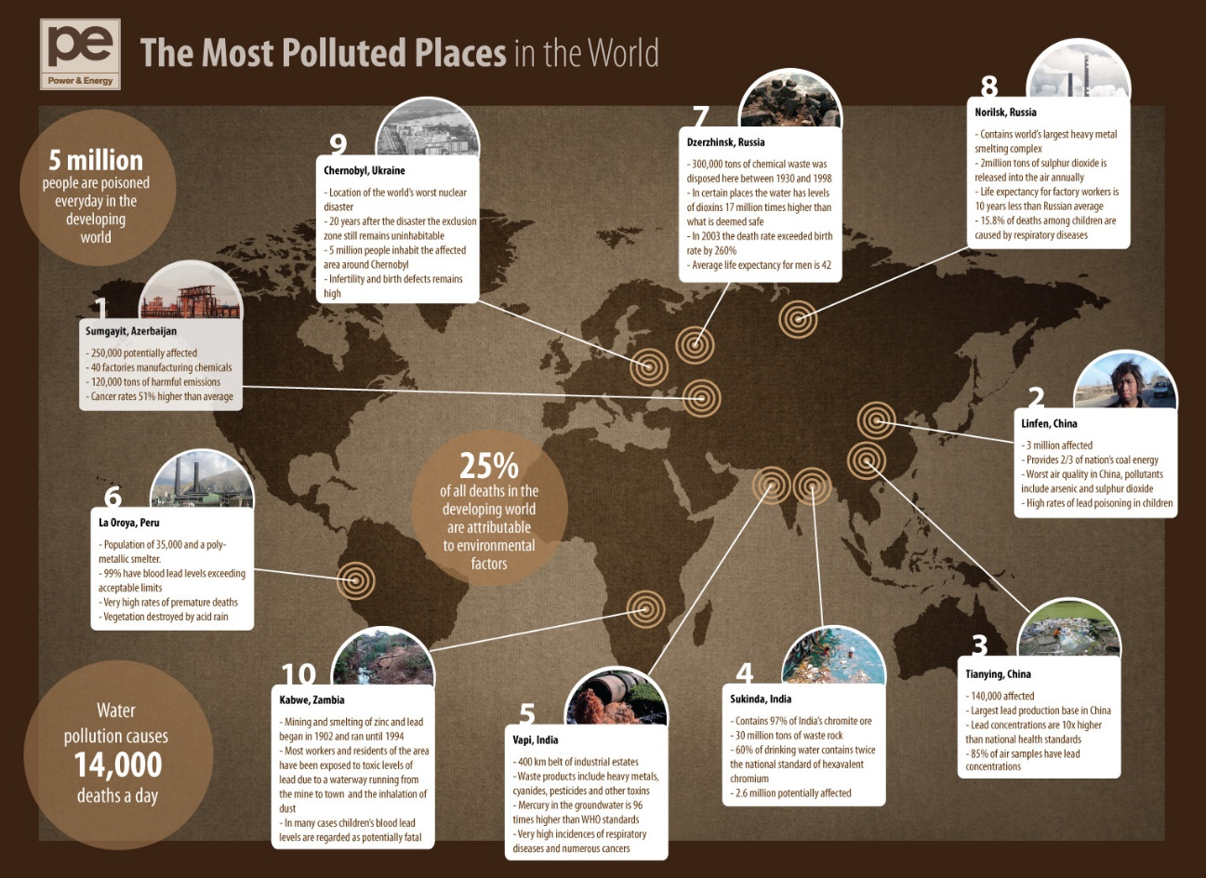
The most polluted places by GDS Infographics used under CC BY 2.0
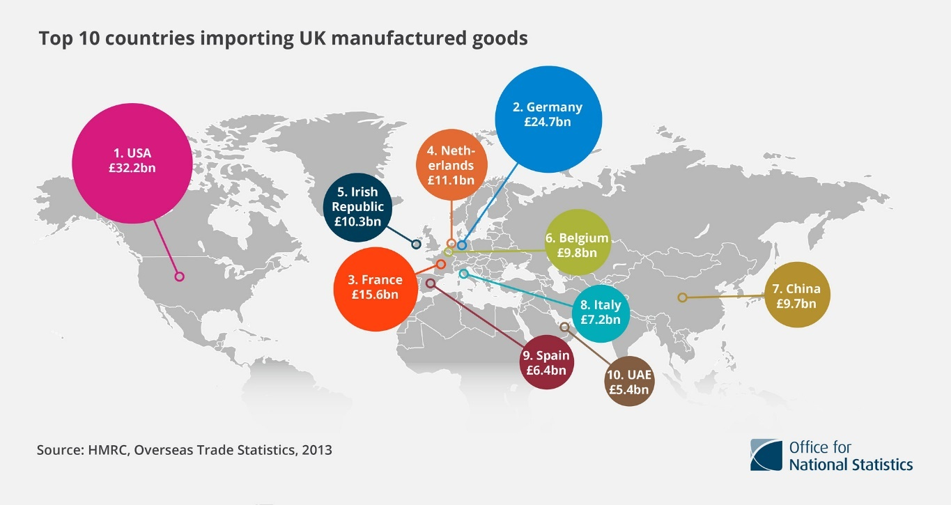
Top 10 countries importing UK manufactured goods by Office for National Statistics used under CC BY 2.0
Back to contents

Hierarchical: to present data according to levels
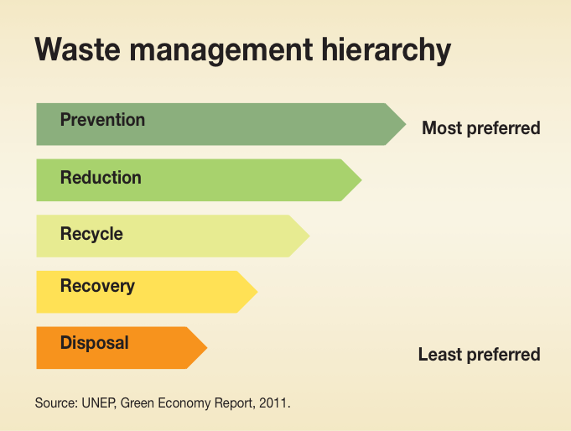
Waste management hierarchy by GRID Arendal used under CC BY-NC-SA 2.0
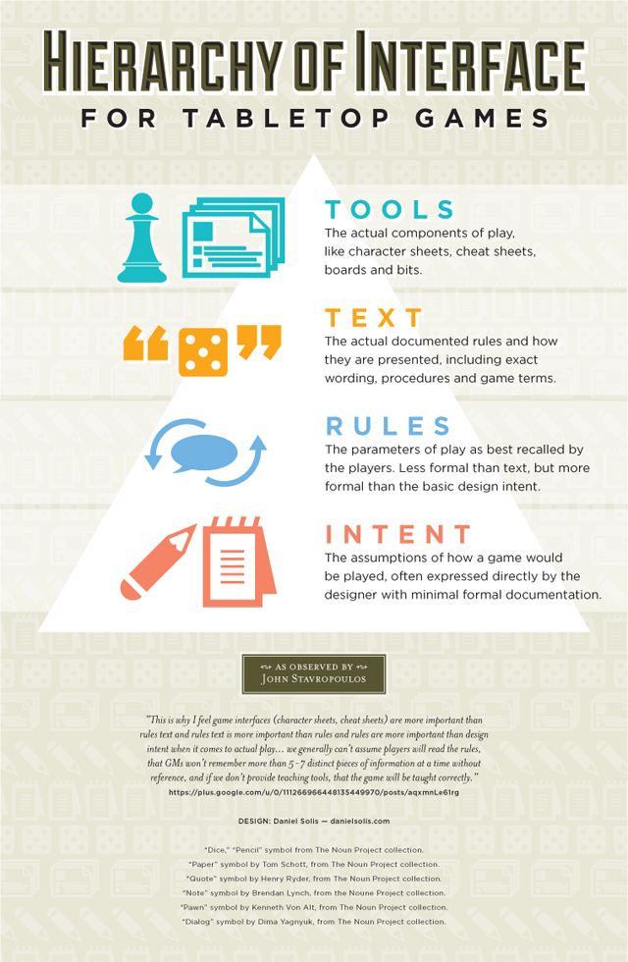
Hierarchy of Interface for Tabletop Games by Daniel Solis used under CC BY 2.0
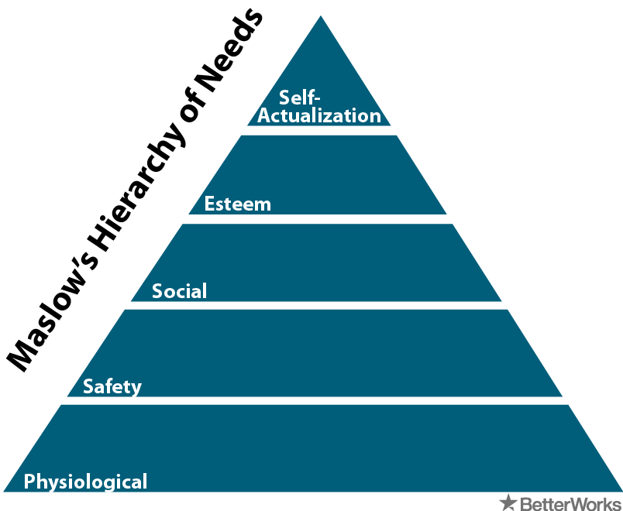
Maslow's Hierarchy of Needs by BetterWorks Breakroom used under CC BY 2.0
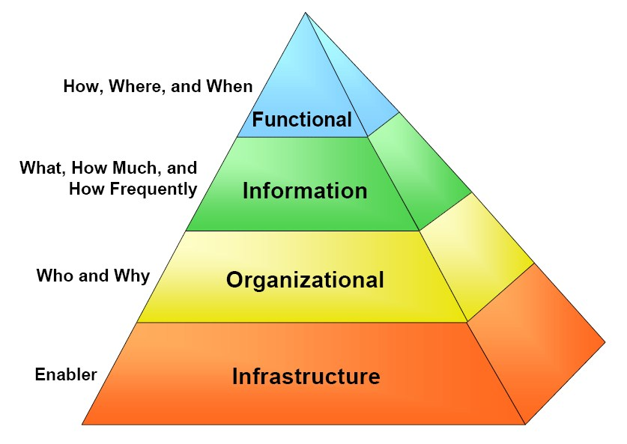
Treasury Enterprise Architecture Framework Concept from Wikimedia Commons – Public Domain
Back to contents

Visualised numbers: to add visual interest to numbers
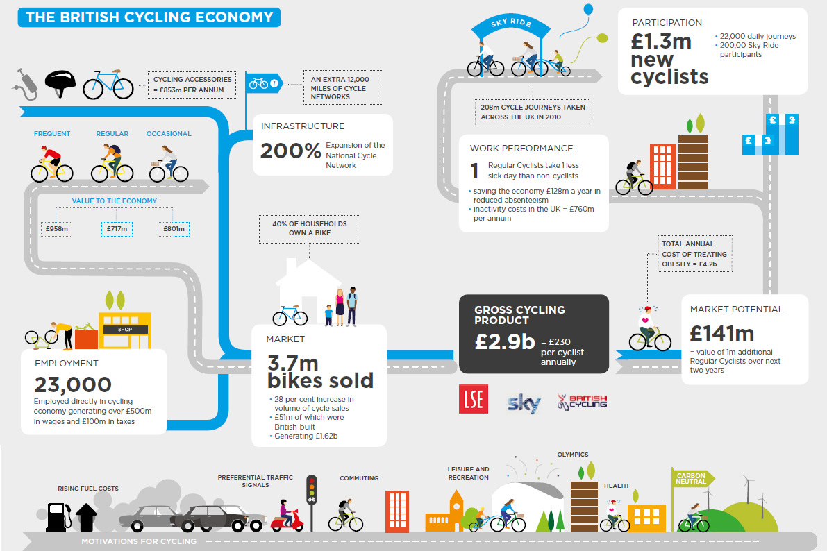
British Cycling Infographic by Andreas Kambanis used under CC BY 2.0
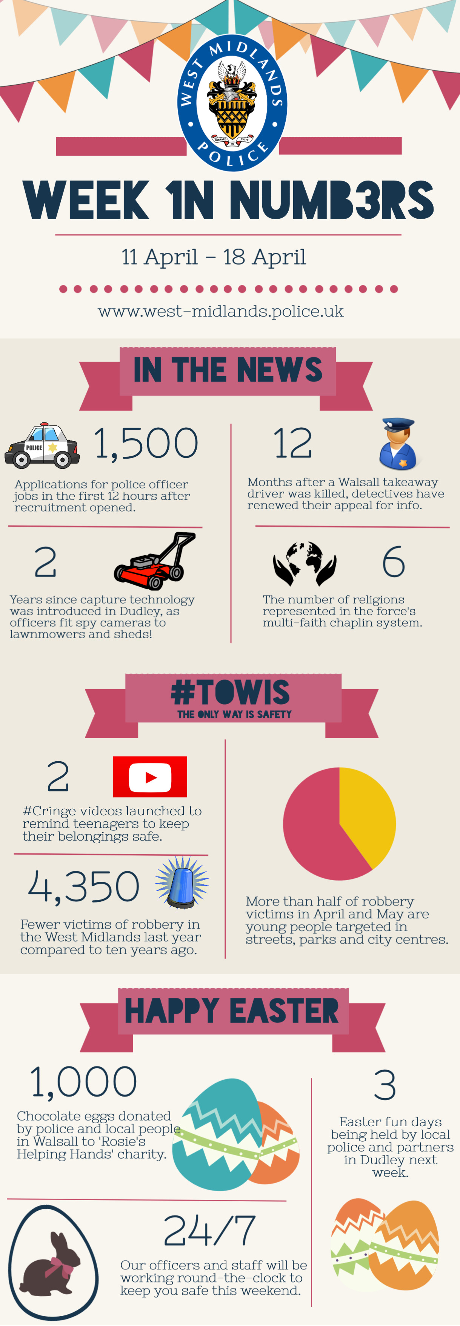
Week in numbers by West Midlands Police used under CC BY-SA 2.0
Back to contents

Creating Infographics: The Process
- Choose your topic and ensure it is relevant and engaging.
- Define your audience. This will dictate your content depending on their prior knowledge of the topic.
- Define your aims and objectives to give the infographic purpose and structure.
- Research your topic and find images to effectively illustrate your key points.
- Organise your information, references and data in a clear and visually appealing design.
- Choose a digital tool and get creating.
Back to contents

Digital Tools for Creating Infographics

Visme
Getting Started with Visme Infographics (YouTube Video)
Visme website

Piktochart
Piktochart infographic design tips (YouTube videos)
Piktochart website
Back to contents

Summary
You have reached the end of this resource. This information has been adapted from the Introduction to infographics tutorial.
Why not look at some of our other Research Skills and Critical Thinking resources? Book onto a Workshop or take an Online Tutorial.
Remember to reflect on and record your skills development using mySkills.
Visit our FAQs: Library FAQs
Get in touch: library@sheffield.ac.uk
Back to contents

References
‘Infographic’ (2015) in Stevenson, A. (ed.) Oxford Dictionary of English. 3rd edn. Available at: https://www.oxfordreference.com/display/10.1093/acref/9780199571123.001.0001/m_en_gb0994544 (Accessed: 21 July 2023).
McCandless, D. (2009) Information is beautiful. London: Collins.
McCandless, D. (2010) The beauty of data visualization. August. Available at: https://www.ted.com/talks/david_mccandless_the_beauty_of_data_visualization (Accessed: 21 July 2023).

Full URLs
David McCandless: http://davidmccandless.com/
Information is beautiful website: https://informationisbeautiful.net/
The beauty of data visualization (TED talk): https://www.ted.com/talks/david_mccandless_the_beauty_of_data_visualization?utm_campaign=tedspread&utm_medium=referral&utm_source=tedcomshare.
Information is beautiful (book): https://find.shef.ac.uk/permalink/f/15enftp/44SFD_ALMA_DS21203368840001441
Top 10 countries importing UK manufactured goods: https://flic.kr/p/ptkS7X
Office for National Statistics: https://www.flickr.com/photos/statisticsons
CC BY 2.0: https://creativecommons.org/licenses/by/2.0/
Household Taxes, 2012/13: https://flic.kr/p/oeaWU6
Children's Deaths linked to the Environment: https://flic.kr/p/SPpcpk
DES Daughter: https://www.flickr.com/photos/diethylstilbestrol/
CC BY-NC-SA 2.0: https://creativecommons.org/licenses/by-nc-sa/2.0/
Cloud computing: https://flic.kr/p/oCeut7
Girls Education Infographic: https://flic.kr/p/uGyVLv
Ukaid: https://www.flickr.com/photos/dfid/
Self-Care: https://flic.kr/p/uThEUo
Pain Pix: https://flic.kr/p/uThEUo
Advantages and Disadvantages of Wind Power: https://flic.kr/p/77VqzU
GDS Infographics: https://www.flickr.com/photos/gdsdigital/
Stress vs Productivity: https://flic.kr/p/77RspM
Lung cancer 1971-2011: https://flic.kr/p/h7ihFw
Can I upload: https://flic.kr/p/dQogba
Giulia Forsythe: https://www.flickr.com/photos/gforsythe/
The journey of tweet: https://www.flickr.com/photos/gdsdigital/4157295889/
Ten steps to building an IES system: https://flic.kr/p/25T8pAH
GRID Arendal: https://www.flickr.com/photos/gridarendal/
Top Baby Names: https://flic.kr/p/fAhef9
Internet Usage: https://flic.kr/p/oC3DKY
CC BY-NC-ND 2.0: https://creativecommons.org/licenses/by-nc-nd/2.0/
Mars Mission: https://flic.kr/p/7UYRSK
What is the big picture?: https://flic.kr/p/FzCsqe
The most polluted places: https://flic.kr/p/7NicRa
Waste management hierarchy: https://flic.kr/p/ReKcv5
Hierarchy of Interface for Tabletop Games; https://flic.kr/p/bQQPi8
Daniel Solis: https://www.flickr.com/photos/daniel_solis/
Maslow's Hierarchy of Needs: https://flic.kr/p/9VjtZA
BetterWorks Breakroom: https://www.flickr.com/photos/betterworksinc/
Treasury Enterprise Architecture Framework Concept: https://commons.wikimedia.org/wiki/File:Treasury_Enterprise_Architecture_Framework_concept.jpg#/media/File:Treasury_Enterprise_Architecture_Framework_concept.jpg
Wikimedia Commons: https://commons.wikimedia.org/wiki/Main_Page
British Cycling Infographic: https://flic.kr/p/afgqgX
Andreas Kambanis: https://www.flickr.com/photos/andikam/
Week in numbers infographic: https://www.flickr.com/photos/westmidlandspolice/13911168173/
West Midlands Police (on Flickr): https://www.flickr.com/photos/westmidlandspolice/
CC BY-SA 2.0: https://creativecommons.org/licenses/by-sa/2.0/
Getting Started with Visme Infographics (YouTube Video): https://youtu.be/OQV5-GemEqY
Visme website: https://www.visme.co/
Piktochart infographic design tips (YouTube videos): https://www.youtube.com/playlist?list=PLFu_9xKHBzHRkmFpbI6e9yfvNXvgY52wX
Piktochart website: https://piktochart.com/
Introduction to infographics tutorial: https://vle.shef.ac.uk/bbcswebdav/xid-48027590_1
Research Skills and Critical Thinking Workshops and Tutorials: https://www.sheffield.ac.uk/library/study/research-skills
mySkills: https://www.sheffield.ac.uk/skills/myskills
Library FAQs: https://libraryhelp.shef.ac.uk/
Back to Contents

Last reviewed: September 2024
Review due: Summer 2025

Except otherwise noted, this work by The University of Sheffield Library is licensed under the Creative Commons Attribution-NonCommercialShareAlike 4.0 International License. To view a copy of this license, visit http://creativecommons.org/licenses/by-nc-sa/4.0/ .

