# Creating and editing images

## Contents

Contents 1

Aims and objectives 2

Why use images? 2

Think through the following questions when using an image: 2

Editing images 3

Ethical considerations when manipulating images 3

Adapting images owned by someone else 6

Image manipulation and editing 6

Creating images 7

The power and use of colour 7

Using text in images 11

Tools to create images 12

Apps to create images 13

Image composition 14

Summary 21

Image credits 21

References 22

Full URLs 24

## Aims and objectives

We are all navigating an increasingly visual information landscape.

During university and beyond you will be both a **consumer** and **creator** of visual information. This tutorial will help you to understand:

* the **power** of images, and why and how to use them in your work.
* considerations you need to **think about** before using or creating images.
* how to **create** an image.
* how to **edit** an image.

This tutorial will help you to develop the skills to communicate visually in an effective manner, and it contains a lot of information to help you.

Back to Contents

## Why use images?

Visual information can be incredibly powerful – the human brain is more efficient at dealing with images than words, as it processes them in two ways – visually and textually - as we apply textual labels to visual information in our minds.

This ‘dual encoding’ is known as the **Picture Superiority Effect** (Paivio and Csapo, 1973). Also, “pictures access meaning more fully than words and are processed more deeply in the brain.” (Paivio, date as cited in Brown *et al*., 2016, p. 69.)

As more and more work created by students will be shared outside the University, it is important to develop skills which are applicable beyond the academic environment.

“A visually literate individual is both a critical consumer of visual media and a competent contributor to a body of shared knowledge and culture.” (ACRL Visual Literacy Competency Standards for Higher Education, 2011)

Visual content should align with the ideas you are trying to get across. Images “can be used as symbols to represent concepts or to provide visual cues or prompts that influence behaviour or call for action” (Brown *et al*., 2016, p. 68.).

Images may also be your data or source; for example, a photograph of a microscope slide or a historical propaganda poster. In these cases, you might include them in your work as evidence for the conclusions or arguments you are making.

Back to Contents

### Think through the following questions when using an image:

* Will my audience know what I am trying to communicate?
* What might be ambiguous or confusing about my visuals?
* Does the visual content used align with my argument and the ideas I am trying to get across?
* Do the images used add meaning? Images should **not** be used for decoration only.

[Adapted from Brown *et al*., 2016, pp. 86-87.]

Back to Contents

## Editing images

This part of the tutorial will guide you through some considerations you must think about when editing and adapting images to use in your work.

When you edit an image, in addition to knowing how to make alterations, you must think through the ethical considerations of any alterations you make.

### Ethical considerations when manipulating images

The ability to manipulate images using software like Photoshop is empowering but comes with a responsibility to use the technology ethically in a way which does not mislead readers.

“For every adjustment that you make to a digital image, it is important to ask yourself, "Is the image that results from this adjustment still an accurate representation of the original data?" If the answer to this question is "no", your actions may be construed as misconduct.” (Rossner and Yamada, 2004)

When looking at someone else’s image check it against other depictions of the same thing - do they corroborate the representation in the image you have?

“Changes to image files can have significant implications for their meaning, authenticity and reliability. A general awareness of common image manipulations will help you know what to look out for.” (Visual literacy for libraries, p. 3.). Common manipulations include:

#### 1) Colour correction

Correcting the brightness, contrast, and/or colour balance of an image are common manipulations used to improve photos, and these are generally acceptable. However, it is not acceptable if these adjustments obscure data that was present in the original or alter the meaning of the image. If you want to highlight a particular feature this should be done in a transparent way that makes it clear what you have done.

Example:

The colours of the flag have been adjusted in Photoshop, and instead of a Spanish parade, it now appears that the people are carrying the flag of Libya.

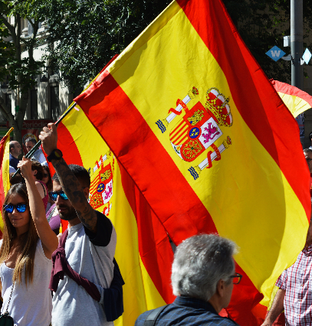

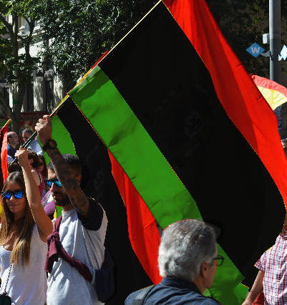

People Holding Flags by Gotta Be Worth It

#### 2) Combining images

If you are combining images together - making one image from one or more original sources - you must ensure that it is clear that the image is a composite, and that what is depicted came from separate sources, otherwise this may mislead readers.

Example:

In the picture of London Bridge, a second photo of a woman has been masked and layered onto the first image in Photoshop, and this lady now appears as though she has visited London. In an expertly Photoshopped image, you may not be able to tell it is not genuine, which deceives the reader.

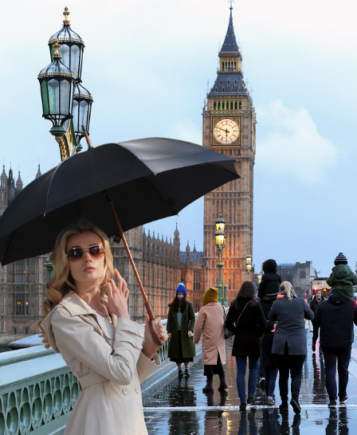

London Bridge by Witizia/Umbrella Girl by ntnvnc

#### 3) Cropping

Cropping may be used to hide information or change the context of an image – this can change the message or evidence in the image.

Example:

The cute picture of a dog in a hat takes on a completely different context when you see it is cropped from a photo of a beggar on the streets.

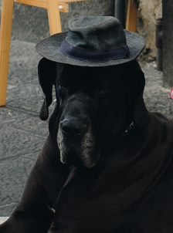

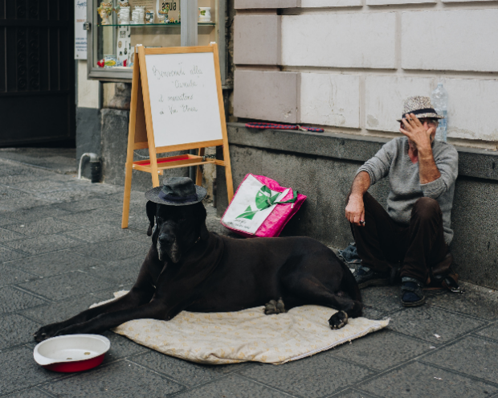

Do You See the Size of That Dog? by Tomas Anton Escobar

This tutorial from LinkedIn Learning has a section on “Cropping and how it affects the meaning in an image”: [Learning to critique photos](https://www.linkedin.com/learning/learning-to-critique-photos). You will need to sign in through the organisational portal as The University of Sheffield.

Read this BBC Future article [The hidden signs that can reveal a fake photo](http://www.bbc.com/future/story/20170629-the-hidden-signs-that-can-reveal-if-a-photo-is-fake) on identifying misleading image manipulation – hidden signs that a photo is fake.

Take Adobe’s [“Real or Photoshop?”](https://landing.adobe.com/en/na/products/creative-cloud/69308-real-or-photoshop/index.html) quiz and see if you can spot images which have been manipulated rather than cleverly photographed.

Even if you are using your own images, or images which are Creative Commons 0 licenced (meaning you can do whatever you please with them), you still need to think about the ethics of how you are manipulating an image to sure you do not mislead your audience.

Back to Contents

### Adapting images owned by someone else

If you do not have your own images to edit you can find freely available images online. However, images are covered by copyright as ‘artistic works’. This means that if you want to use an image created by someone else you need the creator’s permission.

**Just because an image has been shared online doesn’t mean that the owner has given you permission to use it.**

If you want to use or adapt an image which is under copyright you will need to contact the copyright holder to request their permission, unless they are using a Creative Commons (CC) license.

Helpfully, [Creative Commons licenses](https://creativecommons.org/licenses/) enable creators to give permission to others to reuse, adapt, and share their material. Creators can choose which CC license to apply to their work when they share it so that users know what they are allowed to do with it.

There are four main Creative Commons licence types:

* **CC0** – this licence is **free of restrictions**, you can do as you please with the image, commercially or non-commercially, and even attribution is not required (although it is good practice to always provide attribution, even if not legally required).
* **CC BY** – The only restriction of this licence is that **attribution is required**.
* **CC BY-SA** – this license means that if you make adaptations to the original image then you must make your derivative **available under the same license** as the original.
* **CC BY-ND** – this license **does not permit changes** to be made to the original image. Any works licensed under ND **cannot be adapted** – ND meaning ‘No derivatives’.
* The addition of **NC** (NonCommercial) to any licence means the image **cannot be used commercially**.

Take the Library’s tutorial on [Discovering and using images](https://xerte.shef.ac.uk/play.php?template_id=716#page1) to learn where to find sources of public domain images, including those with a CC0 licence, as well as learning more about copyright restrictions.

Back to Contents

### Image manipulation and editing

Your image may require some modification to make it more appropriate, or more interesting. Some simple enhancements to an image can increase its effectiveness, such as **cropping**, **resizing**, **applying filters**, or **adjusting the colour balance** – bearing in mind the ethical considerations of making modifications to images (see Ethical considerations when manipulating images).

**TIP!** If you are using images you have created, the original unprocessed image should always be saved (preferably as TIF - TIF is an uncompressed file type - JPG will produce a smaller file size, but the compression will make your image fuzzy. PNG is a good file type to use for graphics to be used online.), and edits made to a copy of the image.

#### Tutorials

* LinkedIn Learning: [Learning graphic design: Cropping photographs](https://www.linkedin.com/learning/learning-graphic-design-cropping-photographs). You will need to sign in through the organisational portal as TUOS.
* Adobe: [Enhance or correct colors in your photos](https://helpx.adobe.com/uk/photoshop/how-to/adjust-correct-color-balance-photoshop.html)
* Adobe: [Change the image size](https://helpx.adobe.com/uk/photoshop/how-to/image-resizing-basics.html)
* Adobe: [Apply filters](https://helpx.adobe.com/uk/photoshop/how-to/applying-filters-basics.html)

#### Software for image manipulation

To make modifications to an image, you will need to use an image editing tool. Adobe Photoshop is the most well-known and is available on managed desktop computers in the University, but some good free alternatives are available. Try one of the following:

* [Pixlr Editor](https://pixlr.com/) is sophisticated image editing software, quite similar to Photoshop, but freely available on the web. Requires Flash installed to run.
* [Canva](https://www.canva.com/) allows you to upload and edit you own images using simple filters and resizing. No downloads required.
* [GIMP](https://www.gimp.org/) is very powerful but is for the more advanced user as it has a steep learning curve. This requires downloading, and is available from managed desktop PCs, but can also be freely downloaded from the website. It has some good [tutorials](https://www.gimp.org/tutorials/).

Back to Contents

## Creating images

In addition to needing tools to create powerful images, you also need to think about what messages your image is giving to your audience subconsciously, as well as overtly.

Back to Contents

### The power and use of colour

Choosing the right colours is both subjective and scientific, and goes well beyond just personal preference, as colours have “**an extraordinary ability to influence mood, emotions, and perceptions; take on cultural and personal meaning; and attract attention, both consciously and subconsciously**.” (Canva: Color Theory).

A basic understanding of colour theory can help you to choose colours which work well together, send the meaning you wish to convey, and avoid unintended subconscious messages.

The next sections of this tutorial will look at colour theory, and accessibility concerns to bear in mind.

#### Basic colour theory

Colour theory is both a science and an art. Colours change our perceptions and affect how we feel. Using a harmonious colour scheme is important because harmony engages the viewer. Unharmonious colour schemes are either boring or chaotic – one understimulates the viewer, while the other overstimulates – and the brain rejects engagement with either (Color Matters, 2018).

Knowing how to use colour effectively will improve engagement with your work. The first colour wheel was designed by Sir Isaac Newton in 1666, and the same design is used today. Generally, selecting colours from equidistant points on the wheel will produce harmonious colour schemes. These are six common schemes:

##### 1. Colour temperature

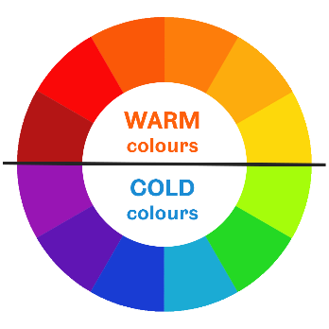

Colours from the WARM side of the colour wheel are vivid and energetic, and tend to advance in space.

Colours from the COLD side of the colour wheel are calm and peaceful, and create a soothing impression.

White, black and grey are considered to be NEUTRAL.

Some colour terms:

**Hue** – the pure colour family on the colour wheel, e.g. green, blue, red, yellow.

**Tint** – hue with white added to lighten and desaturate.

**Shade** – hue with black added to darken and intensify.

**Tone** – hue with grey added to tone down intensity and soften.

##### 2. Analogous colour scheme

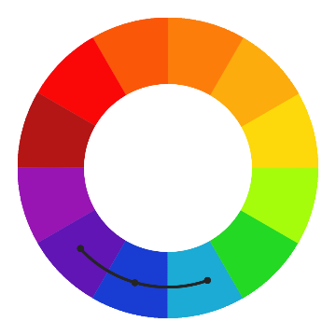

An Analogous colour scheme is based on three colours located next to each other on the colour wheel.

These match well and can give a coherent, comfortable and relaxed feel to designs.

This scheme is best used with the central colour dominating, the second colour to support this and the third colour to accentuate details.

##### 3. Complementary

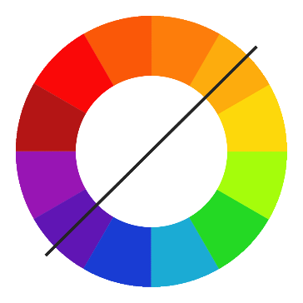

A Complementary colour scheme is based on two colours located on directly opposite sides of the colour wheel.

These high contrast colours create a powerful, vibrant look, and really ‘pop’.

These should be used carefully and in moderation to avoid giving your audience a headache. Ideally use one as the main colour, and the other as an accent. Make use of tints and shades to soften the look.

These two colours are not appropriate to use for text against the opposite colour background.

##### 4. Split Complementary

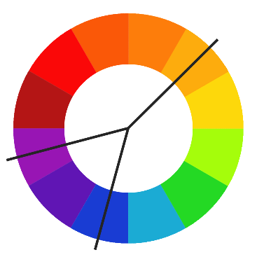

The Split Complementary colour scheme is a variation on the Complementary colour scheme.

It uses one main base colour and the two colours adjacent to its opposite complementary colour.

This scheme still provides strong contrast and vibrancy, but is less jarring than the Complementary scheme, as the second complementary colour softens the look. A common rule of thumb for using a basic, three-color palette in a design is known as the 60-30-10 rule – 60% of your colour should come from your main colour, with 30% from one complementary colour, and the last 10% as an accent of the third colour.

##### 5. Triadic

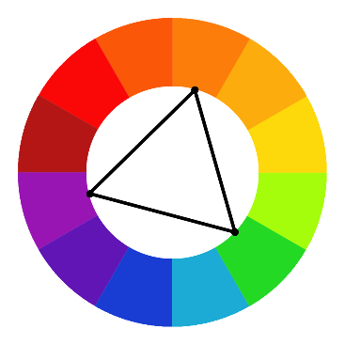

A Triadic colour scheme is based on three colours that are evenly spaced around the colour wheel.

It is a very dynamic, high contrast scheme, but more balanced than the Complementary scheme.

The effect is harmonious, but not monochromatic, and it offers strong visual contrast while retaining balance, and colour richness.

##### 6. Rectangular

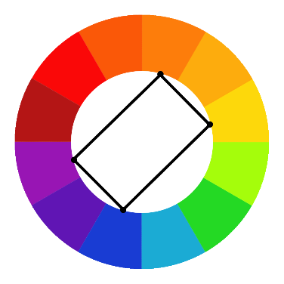

A Rectangular colour scheme uses four colours located in a rectangle around the wheel, in two complementary pairs.

It is a rich yet flexible colour scheme, although it is the hardest scheme to balance.

This scheme looks best when one colour is used as the dominant colour, and when cold and warm shades are balanced evenly.

#### Choosing and using colour

Also consider the general colour preferences of people when creating images. A study by Bakhshi and Gilbert (2015) found that:

* Colourful images are **shared more** online than black and white ones.
* Blue, green, black, and yellow images are shared **much** **less frequently** than red, pink and purple images

#### Finding a colour scheme

The tools below can help you find an appropriate colour scheme for your work:

* [Adobe Color CC](https://color.adobe.com/) - A great tool for helping you select a harmonious colour scheme following the various “colour rules”, such as ‘analogous’ or ‘complementary’ from the drop-down menu. You can move the colour picker around, and the other colours in the palette will change to fit the rules.
* [Coolors](https://coolors.co/) - This tool helps you to select 5 harmonious colours at the click of the space bar. You can ‘lock in’ colours you like, and when you press the space bar the other colours will change to suit to make a palette.

#### Colour and accessibility

Colour should not be the only visual way you communicate a piece of information however, as this may be unintelligible to people with visual stress, dyslexia, or visual impairments including colour blindness.

You need to keep in mind accessibility guidelines for the contrast ratio (this is a numerical ratio showing how visually different the text colour is from the background colour, and therefore how easy it is to pick out the text against that background). Guidelines state that your text should have a contrast ratio of:

**Compliance level AA**: at least **4.5:1** for normal text and **3:1** for large text (Large text is defined as a minimum of 14 point if bold, otherwise a minimum of 18 point.)

**Compliance level AAA (best)**: at least **7:1** for normal text and **4.5:1** for large text. (WCAG, 2008)

You can check your contrast ratio using a website such as WebAIM [Color Contrast Checker](https://webaim.org/resources/contrastchecker/).

Back to Contents

### Using text in images

Using text in images can really help to convey meaning. Research into multimedia learning has found that “the visual and verbal channels complement each other. When pictures and words are integrated...learners are able to construct a deeper understanding than if presented with words or pictures alone.” (Visual literacy for libraries, 2016, p.67)

When adding text to images, some fonts are more appropriate to different mediums of presentation than others.

For example, a serif is a very small stroke attached to the ends of a letter which leads the eye to the next letter. Fonts with a serif are primarily used in print, whereas fonts without a serif – sans serif – are most often used in digital materials as this works better on a screen.

#### Font psychology

“Every font has a unique personality and purpose” (Digital Synopsis, 2017). What is your font saying? The font you use will establish the tone of your work and how it is perceived, so it is important to choose one which conveys your intended meaning. Make sure your font says what your text means!

#### How to use text in images

* Think about the choice of font which will best convey your message.
* Wrapping the text around the image, or interweaving it through the image, can produce striking effects.
* If you want to add text to an image choose one which has empty space – photos that have large, clear areas, or minimally detailed areas will usually work best.
* Add a block of colour over the image to put your text in; add a transparent colour overlay; or make the whole image slightly transparent to make your text ‘pop’ on a busy background by giving you a uniform space for text.
* Choose one or more accent colours from your image for the text to tie the two together; or choose a contrasting colour to make the text stand out boldly.
* If you are using **quotes** in your images, be sure to **reference** them correctly at the end of your work.

Back to Contents

### Tools to create images

There are some excellent free online tools you can use to create the perfect image for your work.

[Canva](http://www.canva.com/)is a great free tool for graphic design, either from scratch or for editing an existing photo of your own. It offers a wide range of features. You can:

* use free photos from a huge library or upload your own.
* straighten, rotate, flip, and add filters to photos.
* add text, resize it, change the fonts and colour, choose a text holder frame, or use the typography layout presets.
* use transparency, overlay different images, add blur.
* add icons, frames, or shapes.
* use and adapt preset templates and create graphs.

The [Canva Design School](https://designschool.canva.com/) offers a huge range of free interactive tutorials - not just on using the Canva software, but on design principles in general, such as font pairing, using white space and creating infographics.

[Piktochart](http://www.piktochart.com/) is an online infographics creator and editor. It helps you to create infographics to successfully communicate information, especially data or statistics which can be dry and hard to convey. Piktochart has more than 500 professionally designed templates updated on a weekly basis, and allows you to:

* use free photos from its library or upload your own.
* change background colors.
* add text, resize it, change the fonts and colour, or use preset styles.
* add icons, shapes, or frames.
* use and adapt preset templates.
* create and add graphs and charts.
* add maps and video.

[Stencil](https://www.getstencil.com/) offers both free and paid for models, with the free version allowing you to create up to 10 images a month. The free version allows you to quickly create an image from those available, but you cannot upload your own. Stencil allows you to:

* use images from a huge collection of copyright free images sourced from Pixabay and Pexels.
* flip, and add filters to photos.
* use transparency, add blur, and add colour overlays.
* add icons.
* add text with effects such as drop shadow.
* use and alter preset templates.

Most online image creation tools include freely available, copyright free images that you can use without worrying about permissions, and they allow you to add text and more to create the image that conveys the message you need for your work.

Back to Contents

### Apps to create images

If you need to create images for your work on the go, there are some free apps you can download to your device which can help you.

[Canva app](http://www.canva.com/app) is a great free tool for graphic design. It is available for both Apple and Android platforms and allows you to do many things that you can do in the online version of Canva. You can:

* use free photos from a large library or upload your own from your camera roll.
* create for a range of social media preset sizes or choose your own size.
* add filters to photos.
* add text, resize it, change the fonts and colour, or use the typography layout presets.
* add icons, frames, or shapes, and change the colours of these.
* use and adapt preset templates.

[PicMonkey](http://www.picmonkey.com/mobile-app) is a free app for editing and transforming your photos and adding text to images. It is available for both Apple and Android platforms. You can:

* Touch up photos with smooth, blemish fix, whiten, brighten, and nip/tuck – to reduce or fill areas, for example chins and lips – all with simple touch and drag.
* Crop and make image adjustments such as exposure, contrast, saturation, clarity, shadows, temperature.
* add blur and special effects filters to photos.
* add text, and alter the font, colour, opacity and size.
* freehand draw onto images.
* add icons and stickers and alter the colours of these.

Typorama is a free app for adding typography to photos and can also be used to edit images. It is available for both [Apple](https://apps.apple.com/us/app/typorama-text-on-photo-editor/id978659937) and [Android](https://play.google.com/store/apps/details?id=in.typorama.typorama) platforms. Search for it on your phone’s app store. You can:

* use free photos sourced from CC0 site Pixabay or upload your own from your camera roll.
* create for a range of social media preset sizes or choose your own size.
* add typography in set styles, with premium options available to pay for.
* adapt the presets with text transparency, colours, two-colour gradients, drop shadows.
* erase parts of the text to place it partially behind elements in images to create an interwoven effect.
* add textured overlays, apply filters, or make image adjustments such as exposure, contrast, saturation etc.
* apply vignettes or blur.

Back to Contents

### Image composition

When you are taking a photograph yourself for use in your work, image composition is an important aspect to think about. This section is adapted from CiCS Creative Media’s “An introduction to photography”.

Be clear on the **subject** of a photo. Every photo has a subject – What or who is it? Why is it there? Is it important? Consider these images: what are the subjects?

Here the subject is the broken rubble.

The image is telling the audience a story, using the world as a canvas.

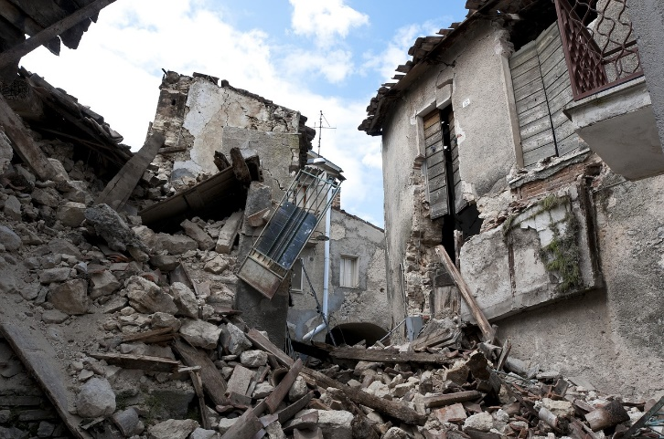

Earthquake by Angelo Giordano

Here the subjects are symmetry, repetition, leading lines and depth.

Geometry and shapes are more important than what the photo is actually of.

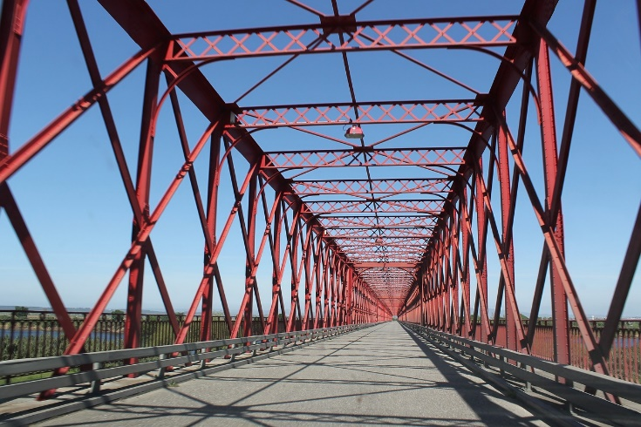

Bridge by GTorres

#### Portrait or landscape?

The terms refer to types of pictures: **landscape** is actually a picture of land, while **portrait** is a picture of a person. Secondly, the terms refer to orientation, where landscape refers to something that is wider than taller, while portrait is something that is taller than wider.

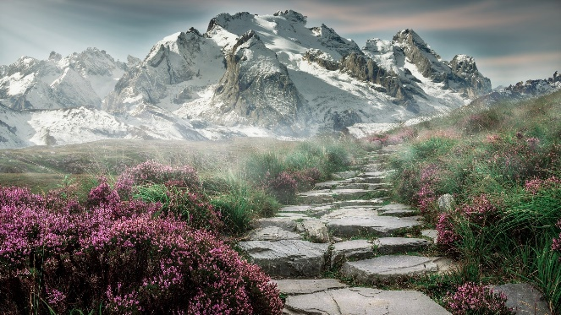

Mountain landscape by kinkate



Bearded Man by Pexels

#### Composition techniques

Composition refers to the way elements are arranged in an image. Watch this short video from CiCS Creative Media to learn more (opens in YouTube): [Composition for photography](https://www.youtube.com/watch?time_continue=194&v=DIW-H3w7foQ).

Composition is important as it is how things will be presented on camera. Knowing how to compose a shot will allow you to build an effective visual style. While there are no rules in photography, there are guidelines and techniques you can follow to make your images more compelling, some of which are listed below.

The **rule of thirds** is a concept in which the frame is divided into nine imaginary section, as illustrated below. This creates reference points which act as guides for framing the image. Specific points of interest can be created where the lines intersect, helping you frame the overall image.

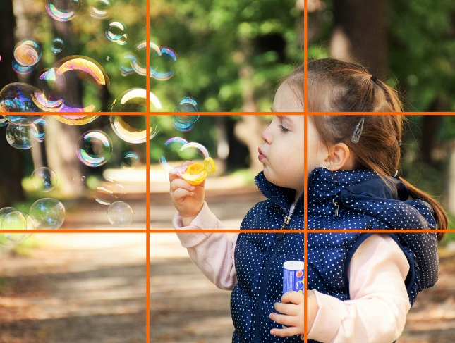

Happy child by ddimitrova

The little girl sits squarely on the right ‘third’ line, with the bubbles aligned along the top ‘third’ line, with one bubble positioned on the top left intersect point.

The **rule of odds** states that framing your subject with 2 surrounding objects, thus making an odd number of 3, creates balance and visual harmony. Humans tend to prefer balance, and feel comfortable with these groupings of 3. Groups of 2 or 4 can sometimes create a sense of competition, whereas odd groupings balance this out. The rule of odds really just refers to the number 3 though, as groups of 5 or more create more density. Larger numbers of objects can still be divided visually into groupings of 3, thus bringing more cohesion to the composition.

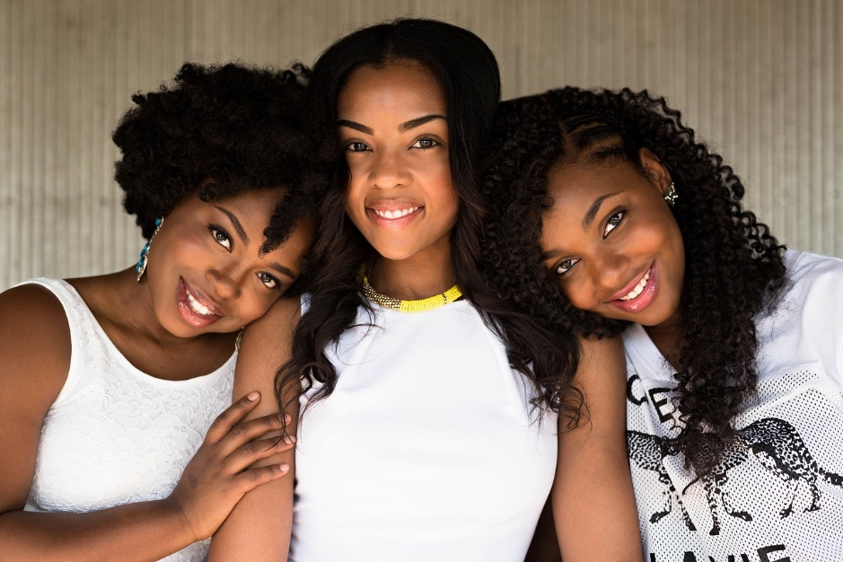

Three people by trevorkellyphotography

**Leading lines** refers to a composition technique whereby the viewer’s eye is attracted to lines that lead directly to the principle subject in the image. As lines in photography naturally draw the viewer’s attention along the paths they create within the image, it’s important to frame your shot in such a way that the lines draw attention to the parts of the image you want them to notice.

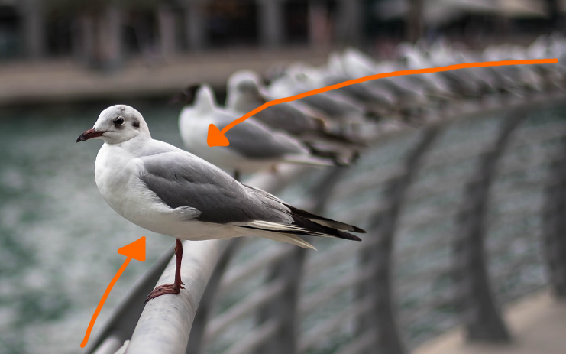

Seagulls by StockShop

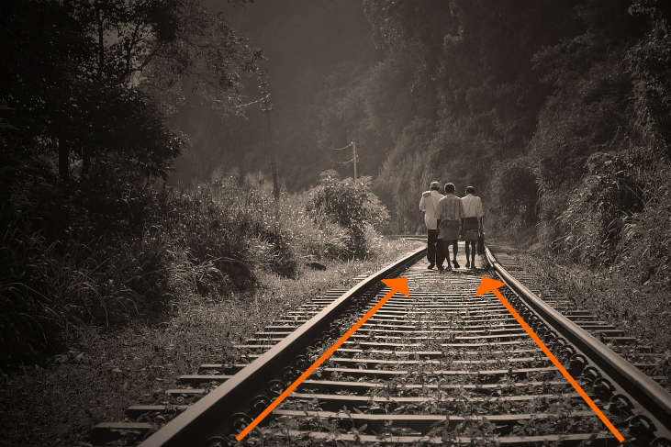

Railroad by nuzree

**Repetition** is a basic concept in the world of art. When you repeat a certain size or shape or colour, you add strength to the overall image. If you want to make a statement, you repeat certain elements again and again. If you repeat something once or twice it becomes more interesting. If you repeat something many times it becomes a pattern and takes on a life of its own. You have two choices in repetition photography – you can either emphasize the repeating pattern, or break it.

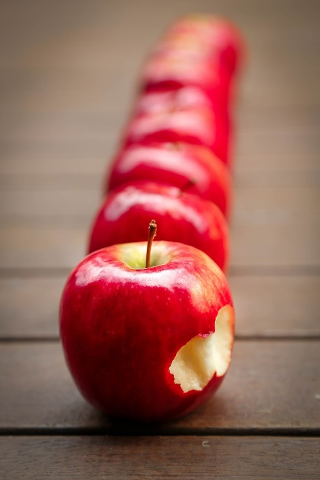

Apples by desertrose_7

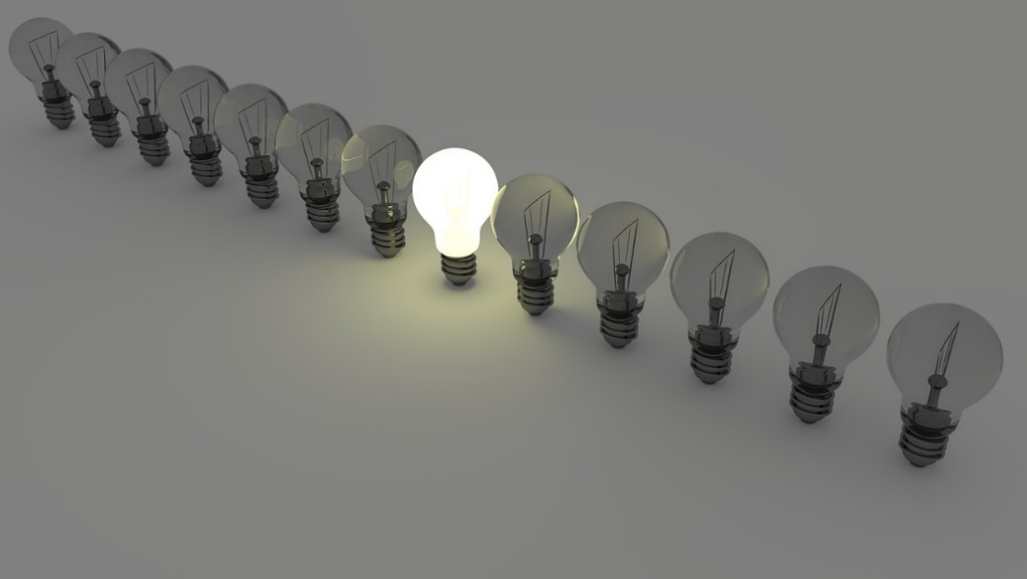

Lightbulbs by ColiN00B

We are surrounded by symmetry and patterns, both natural and man-made. They can make for very eye-catching compositions, particularly in situations where they are not expected. There are four common kinds of symmetry: reflection; rotational; translational; and glide reflection.

**Reflection** is what you see in a mirror. Usually in photography, this means that the left and right halves of the image are almost the same.

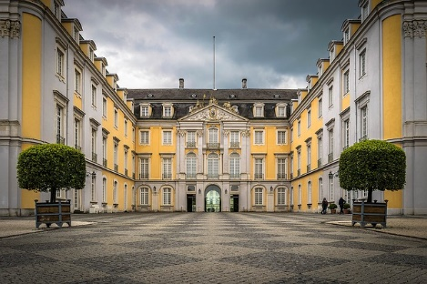

Castle Bruhl by Tama66

A good example of **glide reflection** symmetry are animal tracks, or human footprints in sand. They are seemingly reflected, but also displaced along the axis.

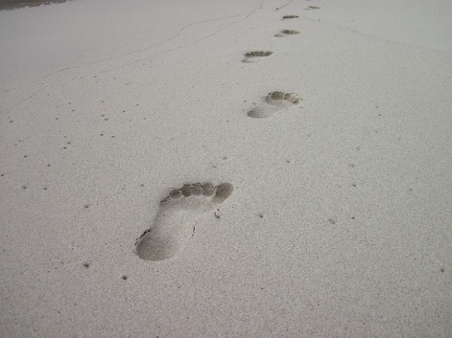

Footprints by Blackout_Photography

**Rotational** symmetry is what you see when a shape or pattern is rotated around a point (also called the origin).



Conifer cone by donwhite84

**Translational** symmetry is when something has undergone a movement, a shift or a slide, in a specified direction through a specified distance without any rotation or reflection.

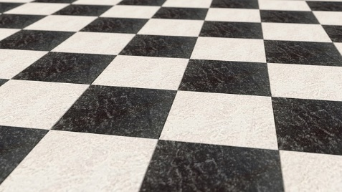

Chess board by CreativeMagic

For more guidance on photography, and information about equipment loan and training, see:

* CiCS Creative Media [digital media hub: videos](https://digitalmedia.sheffield.ac.uk/channel/CiCS%2BCreative%2BMedia%2BChannel/54167032)
* CiCS Creative Media [website](https://www.sheffield.ac.uk/cics/creativemedia)

Back to Contents

## Summary

You have reached the end of this resource. This information has been adapted from the [Creating and editing images tutorial](https://vle.shef.ac.uk/bbcswebdav/xid-48026231_1).

Why not look at some of our other Research Skills and Critical Thinking resources? [Book onto a Workshop or take an Online Tutorial.](https://www.sheffield.ac.uk/library/study/research-skills)

Remember to reflect on and record your skills development using [mySkills](https://www.sheffield.ac.uk/skills/myskills).

Visit our FAQs: [Library FAQs](http://libraryhelp.shef.ac.uk/)

Get in touch: [library@sheffield.ac.uk](mailto:library@sheffield.ac.uk)

[Back to Contents](#_Contents" \o "Back to Contents)

## Image credits

Apples (<https://pixabay.com/en/apples-fruit-red-juicy-634572/>) by Desertrose_7, from [Pixabay](https://pixabay.com/) licensed under [Pixabay License](https://pixabay.com/service/license/).

Bearded man (<https://pixabay.com/en/beard-facial-hair-man-mustache-1867788/>) by Pexels, adapted from the original from [Pixabay](https://pixabay.com/) licensed under [Pixabay License](https://pixabay.com/service/license/).

Bridge (<https://pixabay.com/en/bridge-metal-structure-steel-1392076/>) by GTorres, from [Pixabay](https://pixabay.com/) licensed under [Pixabay License](https://pixabay.com/service/license/).

Castle Bruhl (<https://pixabay.com/en/castle-br%C3%BChl-historically-1395789/>) by Tama66, from [Pixabay](https://pixabay.com/) licensed under [Pixabay License](https://pixabay.com/service/license/).

Chessboard (<https://pixabay.com/en/chess-chessboard-board-marble-679093/>) by CreativeMagic, from [Pixabay](https://pixabay.com/) licensed under [Pixabay License](https://pixabay.com/service/license/).

Conifer cone (<https://pixabay.com/en/conifer-cone-pine-cone-cone-pine-378622/>) by donwhite84, from [Pixabay](https://pixabay.com/) licensed under [Pixabay License](https://pixabay.com/service/license/).

Do you see the size of that dog? (<https://unsplash.com/photos/e6raYkB6Qcs>) by Tomas Anton Escobar, adapted from the original from [Unsplash](https://unsplash.com/) licensed under [Unsplash License](https://unsplash.com/license).

Earthquake (<https://pixabay.com/en/earthquake-rubble-l-aquila-collapse-1665870/>) by Angelo Giordano, from [Pixabay](https://pixabay.com/) licensed under [Pixabay License](https://pixabay.com/service/license/).

Footprints (<https://pixabay.com/en/footprints-sand-beach-footprint-541177/>) by Blackout_Photography, from [Pixabay](https://pixabay.com/) licensed under [Pixabay License](https://pixabay.com/service/license/).

Happy child (<https://pixabay.com/en/kid-child-happy-fun-happiness-1241817/>) by ddimitrova, adapted from the original from [Pixabay](https://pixabay.com/) licensed under [Pixabay License](https://pixabay.com/service/license/).

Lightbulbs (<https://pixabay.com/en/light-bulbs-light-bulb-light-energy-1125016/>) by ColiN00B, from [Pixabay](https://pixabay.com/) licensed under [Pixabay License](https://pixabay.com/service/license/).

London bridge (<https://pixabay.com/en/london-bridge-parliament-big-ben-1763507/>) by Witizia, adapted from the original from [Pixabay](https://pixabay.com/) licensed under [Pixabay License](https://pixabay.com/service/license/).

Mountain landscape (<https://pixabay.com/photos/mountain-landscape-steps-stones-2031539/>) by kinkate, from [Pixabay](https://pixabay.com/) licensed under [Pixabay License](https://pixabay.com/service/license/).

People holding flags (<https://www.pexels.com/photo/photo-of-people-holding-flags-919111/>) by Gotta Be Worth It, adapted from the original from [Pexels](https://www.pexels.com/) licensed under [Pexels License](https://www.pexels.com/license/).

Railroad (<https://pixabay.com/en/rail-road-people-walking-walk-191097/>) by nuzree, adapted from the original from [Pixabay](https://pixabay.com/) licensed under [Pixabay License](https://pixabay.com/service/license/).

Seagulls (<https://pixabay.com/en/animal-birds-seagull-water-fence-2589286/>) by StockSnap, adapted from the original from [Pixabay](https://pixabay.com/) licensed under [Pixabay License](https://pixabay.com/service/license/).

Three people (<https://pixabay.com/en/people-three-portrait-black-3104635/>) by trevorkellyphotography, from [Pixabay](https://pixabay.com/) licensed under [Pixabay License](https://pixabay.com/service/license/).

Umbrella girl (<https://pixabay.com/photos/woman-umbrella-rain-people-girl-3388279/>) by ntnvnc, from [Pixabay](https://pixabay.com/) licensed under [Pixabay License](https://pixabay.com/service/license/).

Back to Contents

## References

99designs (2017) *The fundamentals of understanding color theory*. Available at: [https://99designs.co.uk/blog/tips/the-7-step-guide-to-understanding-color-theory/](https://99designs.co.uk/blog/tips/the-7-step-guide-to-understanding-color-theory/%20%20%20)  (Accessed: 18 May 2018).

Association of College and Research Libraries [ACRL] (2011) *ACRL Visual Literacy Competency Standards for Higher Education*. Available at: <http://www.ala.org/acrl/standards/visualliteracy> (Accessed: 25 July 2017).

Bakhshi, S. and Gilbert, E. (2015) ‘Red, purple and pink: the colors of diffusion on Pinterest’, PLoS ONE, 10(2). doi: <https://doi.org/10.1371/journal.pone.0117148>

Blogging.com (2018) *The purpose of using images in your blog posts*. Available at: <https://blogging.com/images-and-photos/> (Accessed: 8 June 2018).

Brown, N. E. *et al*. (2016) Visual literacy for libraries: a practical, standards-based guide. London: Facet Publishing.

Canva (2020) *Color wheel*. Available at: <https://www.canva.com/colors/color-wheel/> (Accessed: 19 August 2020).

Canva (2018) *How to marry text and images*. Available at: <https://www.canva.com/learn/how-to-marry-text-and-images>/ (Accessed: 15 May 2018).

CiCS Creative Media (no date) Photography: an introduction to photography techniques and using a DSLR [Google Slides Presentation]. Retrieved from The University Of Sheffield Creative Media Training Resources MOLE course.

CiCSTeachingTech (2016) Composition for photography. 14 March. Available at: <https://www.youtube.com/watch?time_continue=194&v=DIW-H3w7foQ> (Accessed: 17 May 2018).

Color Matters (2018) *Basic color theory*. Available at: <https://www.colormatters.com/color-and-design/basic-color-theory> (Accessed: 17 May 2018).

Creative Commons (2017) *About the licenses: what our licenses do*. Available at: <https://creativecommons.org/licenses/> (Accessed: 6 June 2018).

Digital Synopsis (2017) *What different types of fonts mean and how to use them*. Available at: <https://digitalsynopsis.com/design/font-psychology-emotions/> (Accessed: 15 May 2018).

Greenpeace (2018) *Ocean plastic*. Available at: <https://www.greenpeace.org.uk/what-we-do/oceans/plastics/> (Accessed: 15 May 2018).

King, S. (2000) On writing: A memoir of the craft. New York: Scribner.

Lifehacker (2014) *Learn the basics of color theory to know what looks good*. Available at: <https://lifehacker.com/learn-the-basics-of-color-theory-to-know-what-looks-goo-1608972072> (Accessed: 18 May 2018).

OWN (2014). Dr. Maya Angelou: "Be a Rainbow in Someone Else's Cloud". 28 May. Available at: <https://www.youtube.com/watch?v=0nYXFletWH4> (Accessed: 15 May 2018).

Paivio, A. and Csapo, K. (1973) ‘Picture superiority in free recall: Imagery or dual coding?’ Cognitive Psychology, 5(2), 176-206. doi: <https://doi.org/10.1016/0010-0285(73)90032-7>

Rossner, M. and Yamada, K. M. (2004) ‘What's in a picture? The temptation of image manipulation’. Journal of Cell Biology, 166(1), 11-15. doi: <https://doi.org/10.1083/jcb.200406019>

Snicket, L. (2007) Horseradish: Bitter truths you can’t avoid. London: HarperCollins.

Verhoef, P. C., Kooge, E. and Walk, N. (2016) *Creating value with big data analytics: making smarter marketing decisions*. London: Routledge.

WebAIM (2018) *Color Contrast Checker*. Available at: <https://webaim.org/resources/contrastchecker/> (Accessed: 31 May 2018).

World Wide Web Consortium (W3C) (2008) Web Content Accessibility Guidelines (WCAG) 2.0: 1.4 Distinguishable: make it easier for users to see and hear content including separating foreground from background. Available at: [https://www.w3.org/TR/WCAG20/#visual-audio-contrast](https://www.w3.org/TR/WCAG20/%23visual-audio-contrast) (Accessed: 31 May 2018).

Back to Contents

## Full URLs

LinkedIn Learning: Learning to critique photos:

<https://www.linkedin.com/learning/learning-to-critique-photos>

BBC Future: The hidden signs that can reveal a fake photo: <http://www.bbc.com/future/story/20170629-the-hidden-signs-that-can-reveal-if-a-photo-is-fake>

Adobe’s “Real or Photoshop?” quiz: <https://landing.adobe.com/en/na/products/creative-cloud/69308-real-or-photoshop/index.html>

LinkedIn Learning: Learning graphic design: Cropping photographs: <https://www.linkedin.com/learning/learning-graphic-design-cropping-photographs>

Adobe: Enhance or correct colors in your photos: <https://helpx.adobe.com/uk/photoshop/how-to/adjust-correct-color-balance-photoshop.html>

Adobe: Change the image size: <https://helpx.adobe.com/uk/photoshop/how-to/image-resizing-basics.html>

Adobe – Apply filters: <https://helpx.adobe.com/uk/photoshop/how-to/applying-filters-basics.html>

Apple - app store (Typorama):

<https://apps.apple.com/us/app/typorama-text-on-photo-editor/id978659937>

Android – Google Play (Typorama):

<https://play.google.com/store/apps/details?id=in.typorama.typorama>

Pixlr Editor: <https://pixlr.com/>

Canva: <https://www.canva.com/>

GIMP: <https://www.gimp.org/>

GIMP tutorials: <https://www.gimp.org/tutorials/>

Adobe Color CC: <https://color.adobe.com>

Coolors: <https://coolors.co/>

WebAIM Color Contrast Checker: <https://webaim.org/resources/contrastchecker/>

Canva Design school: <https://designschool.canva.com/>

Piktochart: [www.piktochart.com](https://www.piktochart.com)

Stencil: <https://www.getstencil.com/>

Canva app: [www.canva.com/app](http://www.canva.com/app)

PicMonkey: [www.picmonkey.com/mobile-app](http://www.picmonkey.com/mobile-app)

Pexels: <https://www.pexels.com/>

Pexels License: <https://www.pexels.com/license/>

Pixabay: <https://pixabay.com/>

Pixabay License: <https://pixabay.com/service/license/>

Unsplash: <https://unsplash.com/>

Unsplash License: <https://unsplash.com/license>

CiCS Creative Media “Composition for photography” video: <https://www.youtube.com/watch?time_continue=194&v=DIW-H3w7foQ>

CiCS Creative Media digital media hub : videos <https://digitalmedia.sheffield.ac.uk/channel/CiCS%2BCreative%2BMedia%2BChannel/54167032>

CiCS Creative Media web site <https://www.sheffield.ac.uk/cics/creativemedia>

Creating and editing images tutorial: <https://vle.shef.ac.uk/bbcswebdav/xid-48026231_1>

Discovering and using images tutorial:

<https://xerte.shef.ac.uk/play.php?template_id=716#page1>

Research Skills and Critical Thinking Workshops and Tutorials: <https://www.sheffield.ac.uk/library/study/research-skills>

mySkills: <https://www.sheffield.ac.uk/skills/myskills>

Library FAQs: <https://libraryhelp.shef.ac.uk/>

Back to Contents

Last reviewed: September 2024

Review due: Summer 2025



Except otherwise noted, this work by The University of Sheffield Library is licensed under the Creative Commons Attribution-NonCommercialShareAlike 4.0 International License. To view a copy of this license, visit http://creativecommons.org/licenses/by-nc-sa/4.0/.