Searching by site and domain

Uses of the site: feature in most popular search engines.
In this document:
- Search by website type
- Search by country
- Search by Individual website
- Search by sections of a website

Search by website type
Perhaps most useful for study are:
Site:edu | Searches US educational sites
Site:ac.uk | Searches UK educational sites
Site:gov | Searches government websites

Search by Individual website
To search a particular website, enter its domain name after site: in the search box. The domain name is the part after www but before the first forward slash.
Site:bbc.co.uk | Searches the BBC website
Site: worldbank.org | Searches the World Bank website.
Site:Sheffield.ac.uk | Searches the University of Sheffield website
Site:bma.org | Searches the British Medical Association website

Search by sections of a website
This can be useful if you’ve heard that there’s an interesting article on a site, or you remember seeing it but forgot to bookmark it. This can also be a way of browsing an interesting section of a site if it doesn’t have its own search facility.
Here’s a step by step of how to do it:
- Go to the home page of the site section you’re interested in, either using a search engine or by navigating to it from the site home page.
- Look at the URL in your browser address bar:
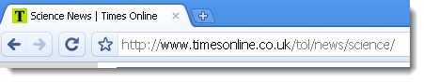
- Copy the URL from the dot after www to the last forward slash:
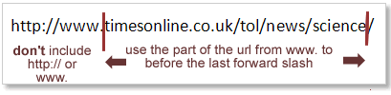
- Go to your search engine and type in site:
- Paste the URL fragment you just copied directly after the colon – without a space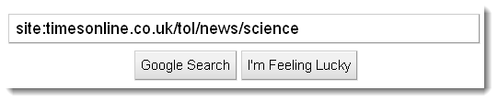
- Add your search terms
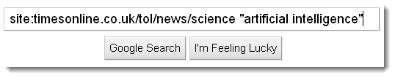

Search by country
Site:in | Indian websites
Site:cn | Chinese websites
Site:de | German websites
Site:jp | Japanese websites
Site:uk | UK websites
These are known as ‘country code top level domains’. There is a more complete list of them on Wikipedia.

